Can you read these words and find one object to match every word?
Write down what you find using sentences like below
.
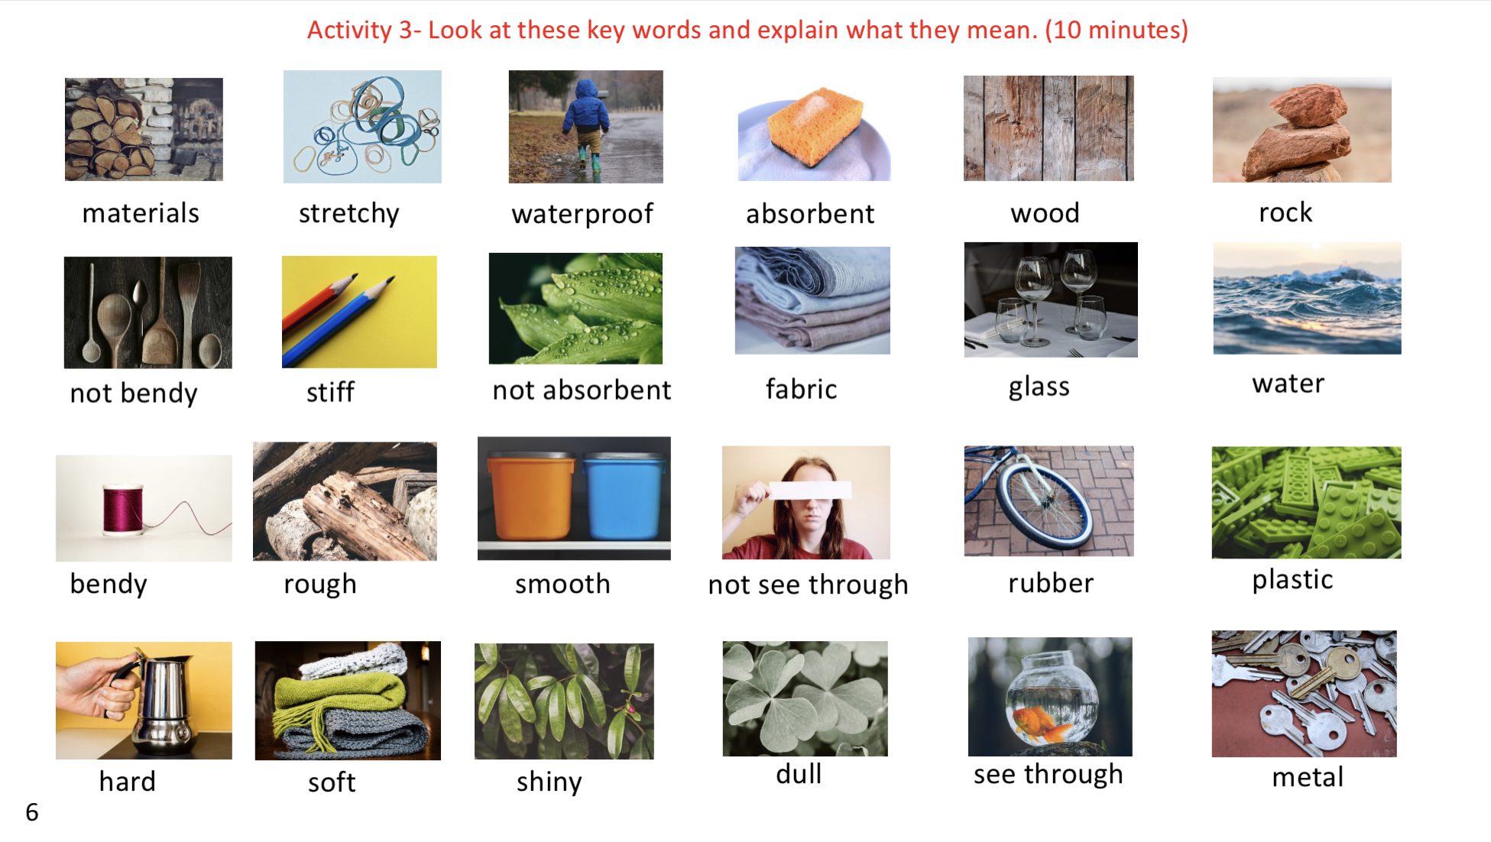
The sponge is absorbent. The cloth is bendy and soft.

