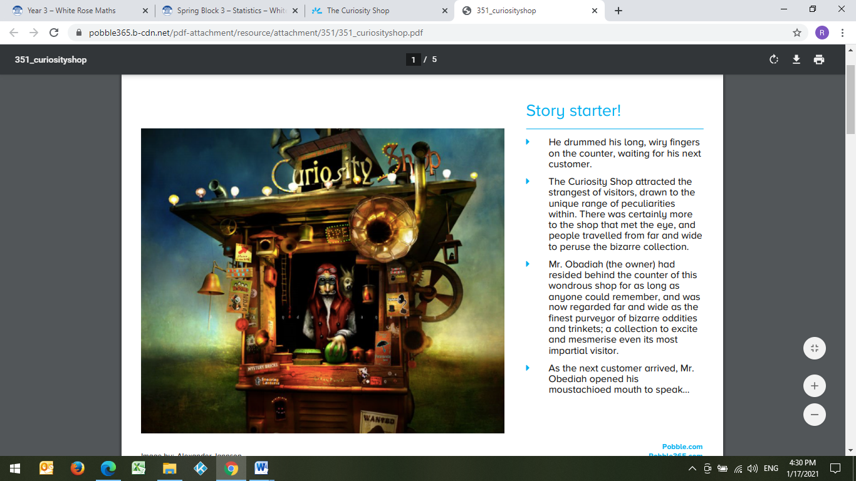

The Curiosity Shop

He drummed his long, wiry fingers on the counter, waiting for his next customer.

The Curiosity Shop attracted the strangest of visitors, drawn to the unique range of peculiarities within. There was certainly more to the shop that met the eye, and people travelled from far and wide to peruse the bizarre collection.

Mr. Obadiah (the owner) had resided behind the counter of this wondrous shop for as long as anyone could remember, and was now regarded far and wide as the finest purveyor of bizarre oddities and trinkets; a collection to excite and mesmerise even its most impartial visitor.

As the next customer arrived, Mr. Obediah opened his moustachioed mouth to speak…