Friday 15th January - English Lesson
Main lesson
Today you are going to create your own dragon.
Try and think about the colour your dragon might be, what it eats, where it lives, what does it like to do, what shape it is, what type of tail it has, does it have a certain personality?
Collect your ideas on a piece of paper like this.
Eats mice
Electric pink
My dragon
Loves to swim

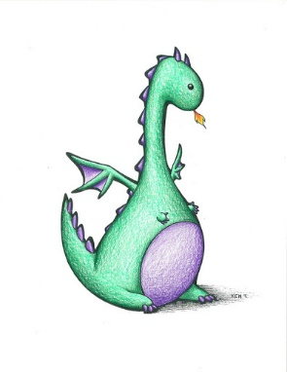
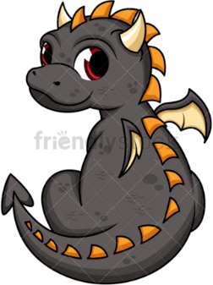
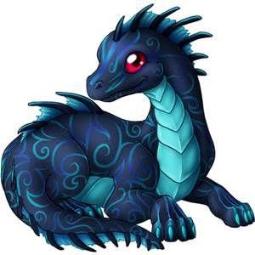
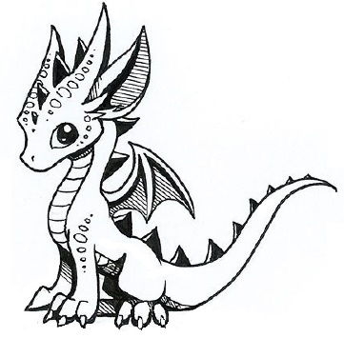

- Can you draw a dragon and label it? (Its key features, eyes, spikes, horns, tail)
- Can you think of a name for your dragon? (Use your imagination for this).
- Can you write 8 sentences using joining words to describe everything about your dragon?

Success Criteria
- Write in full sentences using finger spaces, capital letters and full stops.
- Write at least 8 sentences – if you can do more brilliant!
- Use ‘and, because, so’ in each sentence.
- Use exciting vocabulary including fantastic adjectives.

Please send a picture on seesaw of your dragon and description.
We can’t wait to see them all.

