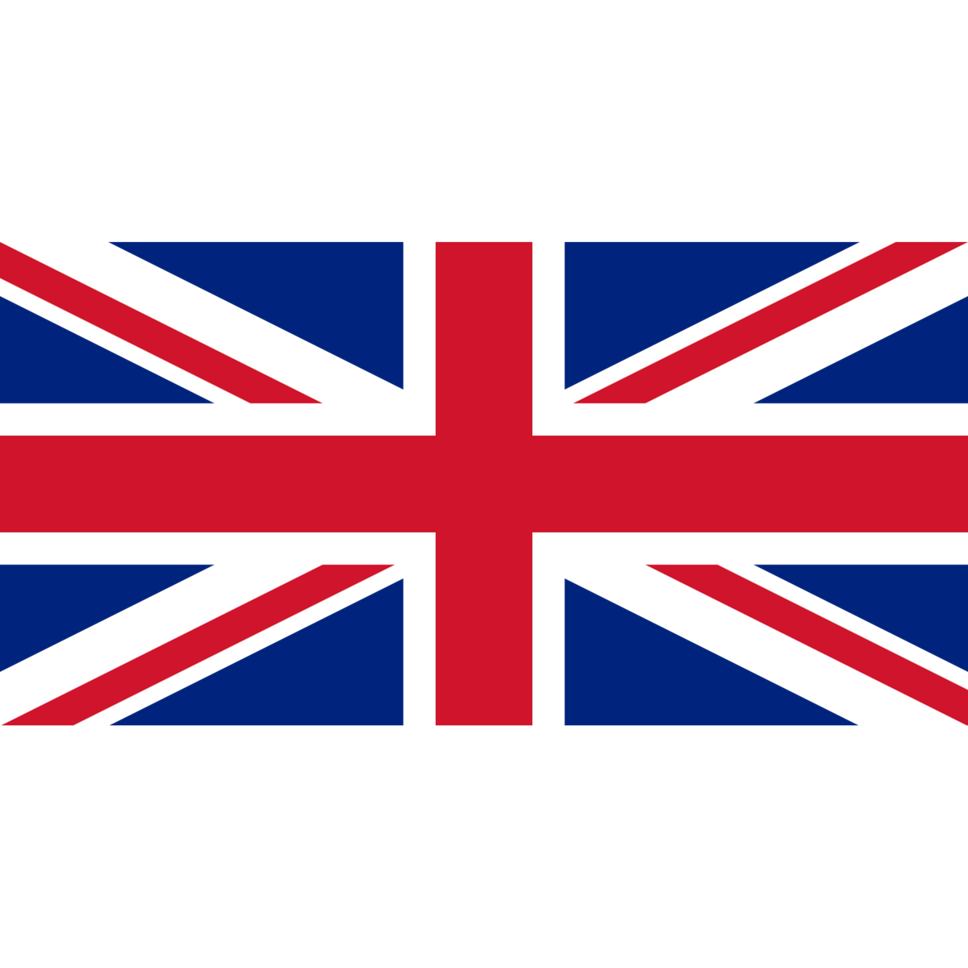
Thursday 14th January 2021.

Can I describe and draw places I have been to in the United Kingdom?
Places I have visited in the U.K.

____________________ | ____________________
___________________ | _____________________

