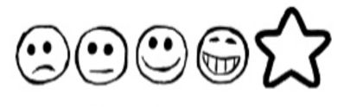
Friday 15th January 2021. My Spider Story

Can I use my own ideas to write a story?
Can I use my sounds to spell my words?
Can I write in sentences?

____________________________________________________________________________________________________________________________________________________________________________________________________________________________________________________________________

____________________________________________________________________________________________________________________________________________________________________________________________________________________________________________________________________

