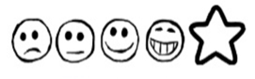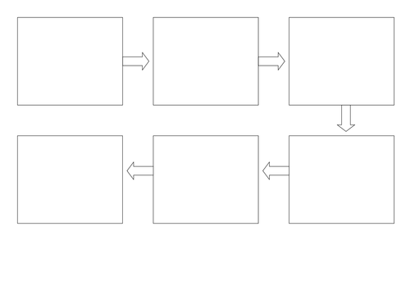

Can I use my own ideas? Can I talk about the beginning, middle and end of my story?

My Story Map by ______________ Thursday 14th January 2021