FRUITY BOATS – SINKING AND FLOATING EXPERIMENT
Objects float when they are less dense than the fluid they are in. If you dropped a tennis ball and a marble into a bucket of water the marble would sink and the tennis ball float. This is because a tennis ball is full of air (it is not very dense) and a marble is solid (it is very dense). Huge ships float because although they are extremely heavy, they have a lot of empty space inside. Lemons float as they have lots of air pockets in the thick skin. The inside of a lemon actually sinks!
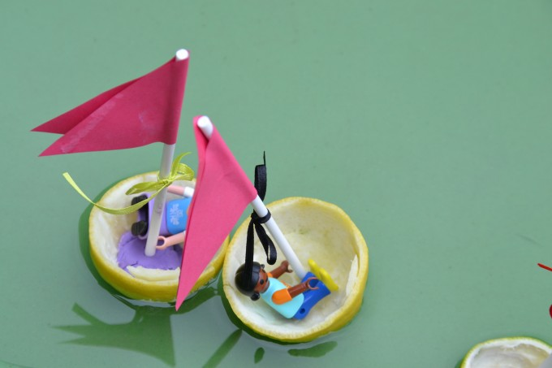
What do you think of our fruity lemon boats?

WHAT YOU NEED TO MAKE A FRUITY BOAT
- Lemons, limes, melon or anything else with a thick skin.
- Small sticks – we used cake pop sticks
- Paper to make sails
- Double sided tape – for the sails.

HOW TO MAKE A FRUITY BOAT
- Hollow out the fruit, I managed to cut the lemon and lime so we could still use them.
- Decide how to cut the fruit to make the best shaped boat.
- If the skin is thick enough, stick the stick into the flesh, else use a bit of play doh to keep it secure.
- Add your sail and see if it floats.
( ask an adult to help with the cutting )

FRUITY BOAT – EXTENSION ACTIVITY
If you add more weight do the boats still float or sink?
Can you predict which boats will sink and which float before putting them on the water? Make a table to show your results.
What happens if you blow the boats? Can you have a race with a friend?
How can you make the boat change direction?

