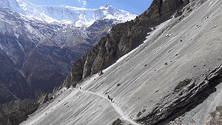
Planning Notes



