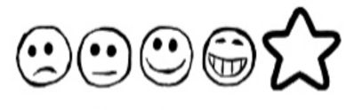
Wednesday 13th January 2021. Mini-beast hunting!

Can I use my sounds to spell words?
Can I write some sentences?

A picture of my hunt

First, I went to

Next, I went to______________________________________________________________

________________________________________________________________
After that, I went to______________________________________________________________

________________________________________________________________

Finally, I went to______________________________________________________________

