Tuesday 12th January - English Lesson

We are starting a new book! Our new novel is ‘How to train your dragon’. We know many of you will have enjoyed these films but we thought it would be great to see what fantastic writing we could produce from reading the novel.

Starter:
Can you look at the front cover of the book and have a think about what the story might be about.
Can you write 3 questions about what you would like to find out about the book?
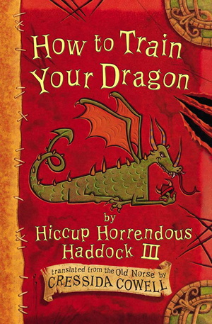

Main Lesson:
Listen to the Author Cressida Cowell reading ‘How to train your dragon’ Book 1, Chapter 1 – First Catch your dragon.
Read up to minute 5.24
https://www.youtube.com/watch?v=uWhNzQUfmSE&safe=active
Questions to discuss:
Who are the main characters so far in the story?
What do we know about Hiccup?
What are Vikings like so far?
How do you feel about catching a dragon?

Use this map for your writing today.

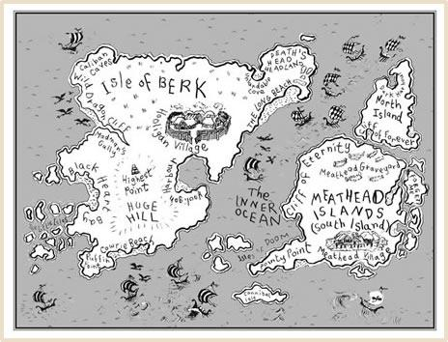

Can you write 8-10 questions about what you would like to know about Isle of Berk?
See if you can use these different question starters: How, Why, Where, Who, When, Which.

You can listen to the end of Chapter 1 ready for our lesson tomorrow.
https://www.youtube.com/watch?v=uWhNzQUfmSE&safe=active

Looking forward to seeing your work on SeeSaw.

