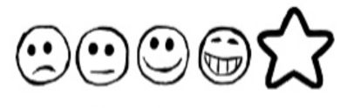
Tuesday 12th January 2020. SPIDER FACT FILE

Can I use my sounds to spell words?
Can I write down some facts in sentences?

What it looks like
Where it lives
What it eats
An unusual fact
Other interesting information

My Drawing of a Spider

