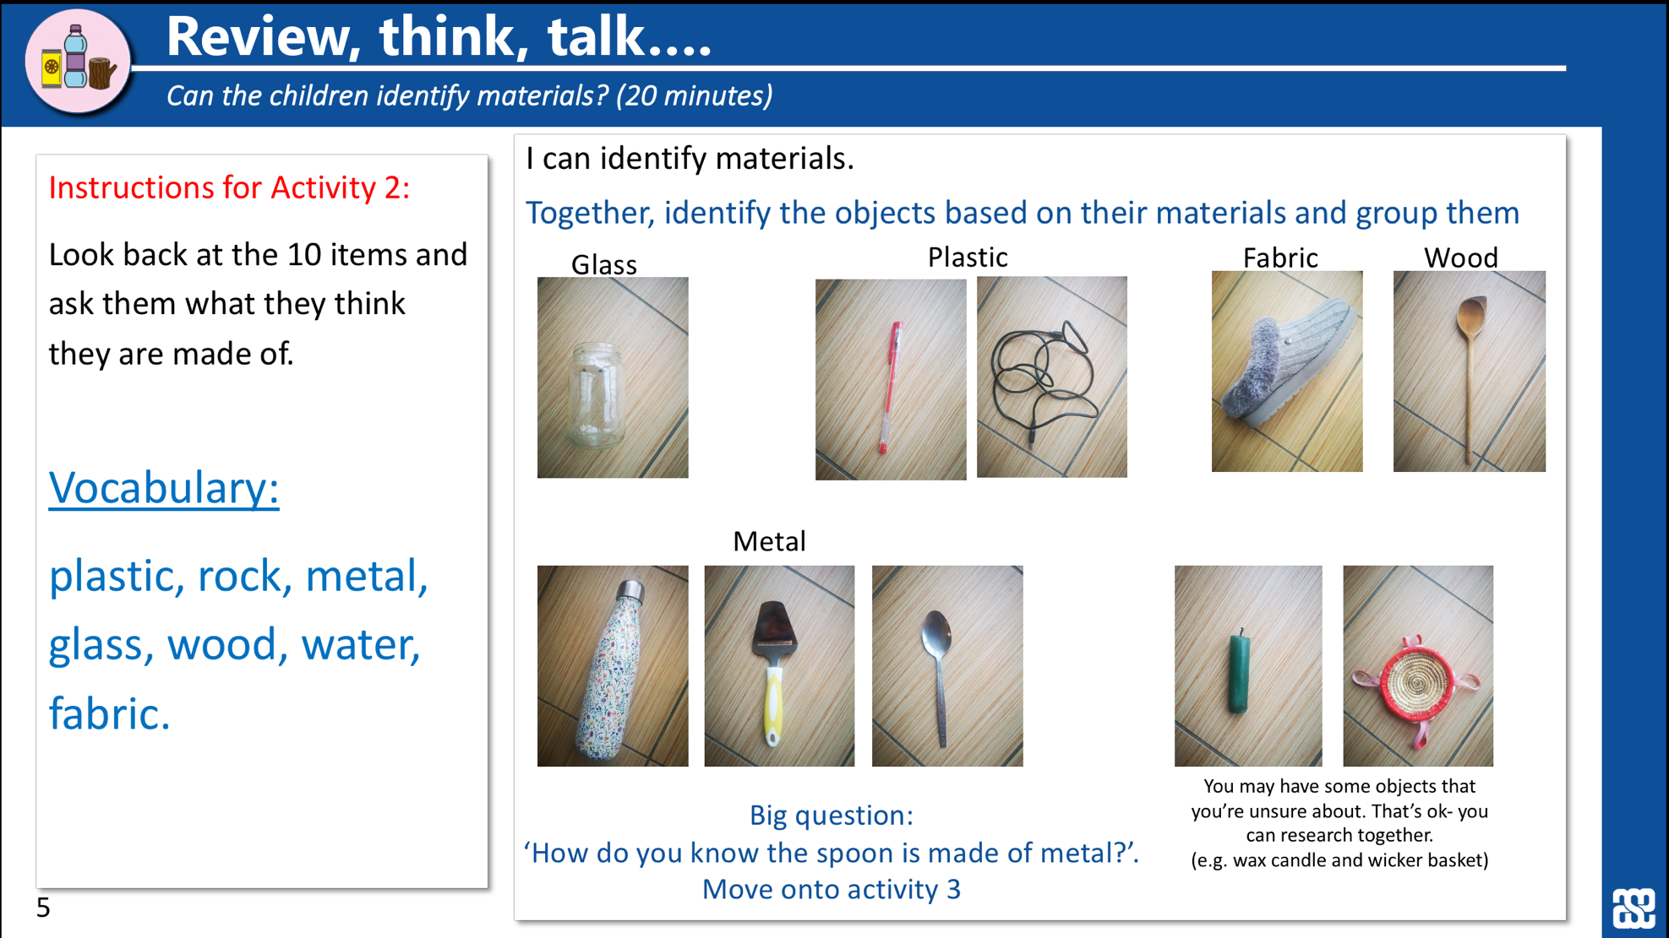

Can you sort your items based on what they are made from. Draw a picture and label all the items you have found below.

Can you write a few sentences explaining what you found out?

