Monday 11th January English Lesson
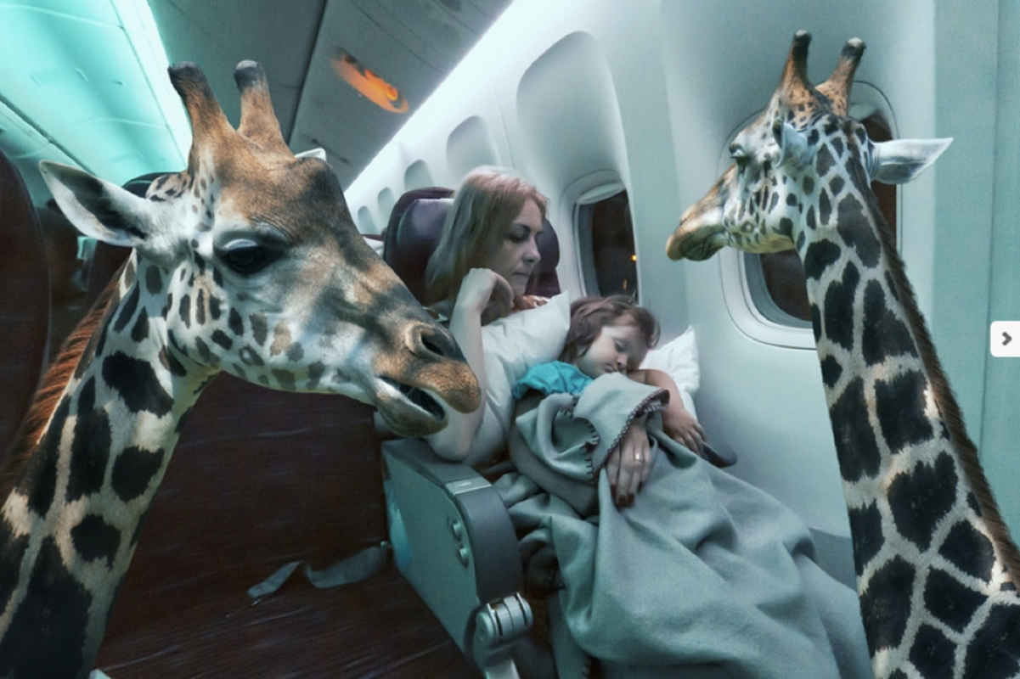
Animal Airlines

Starter:
These sentences need to be better. Can you read them and then re-write the sentences so they are more exciting to read?
The giraffe had a neck and horns. He turned his head around the cabin and looked at the girl with his eyes. This was a strange flight.
Main Lesson:
Can you write a list of animals you would like to work on your animal airline?
(You might want to use bullet points for your list).
Can you write what job these animals will do?
Examples could be: pilot – who’s flying the plane, making the food, giving out the drinks, playing games with children, playing music to help people sleep etc. Try and use your imagination.
Can you choose 4 of your animals on your airline and write in full sentences using your joining words explaining their jobs in more detail.
It would be great to see some adjectives to describe your animals too.

