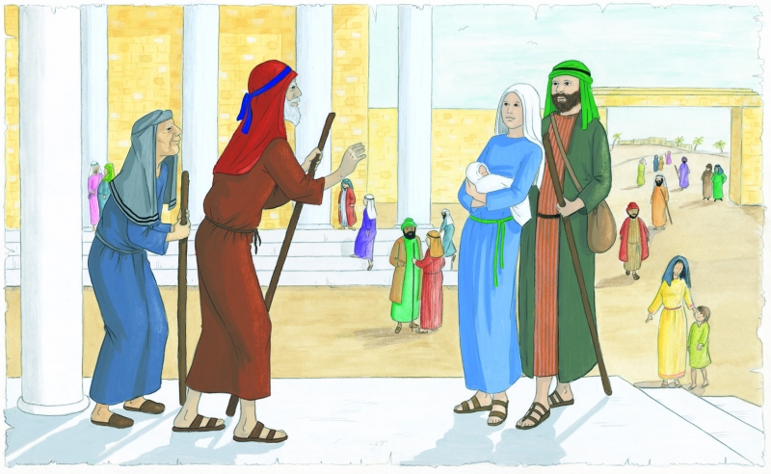

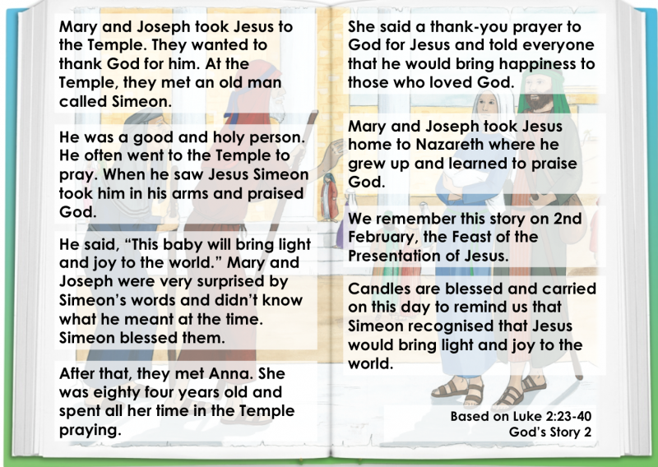

- Who are the special people in this story?
- What did Simeon say about Jesus?
- What do you think this meant?
- How do you think Jesus brings light to the world?
- How can we bring joy to others?

