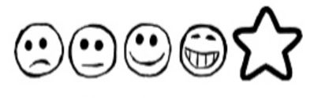
Monday 11th January 2020. Sidney the Spider’s Shed

Can I use my own ideas to write labels?
Can I use my sounds to spell my words?
Can I complete the sentences?
Drawing of the shed with labels

I could hide in a ______________________________________________

I could hide in a ______________________________________________

I could hide under a ___________________________________________

I could hide on top of__________________________________________

I could hide next to____________________________________________

