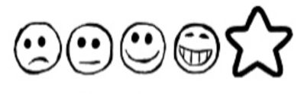
Friday 8th January 2020. Sidney the Spider

Can I use my own ideas to write a letter to the other Spiders?
Can I use my sounds to spell my words?

Dear Susie and Stanley,

Sidney

