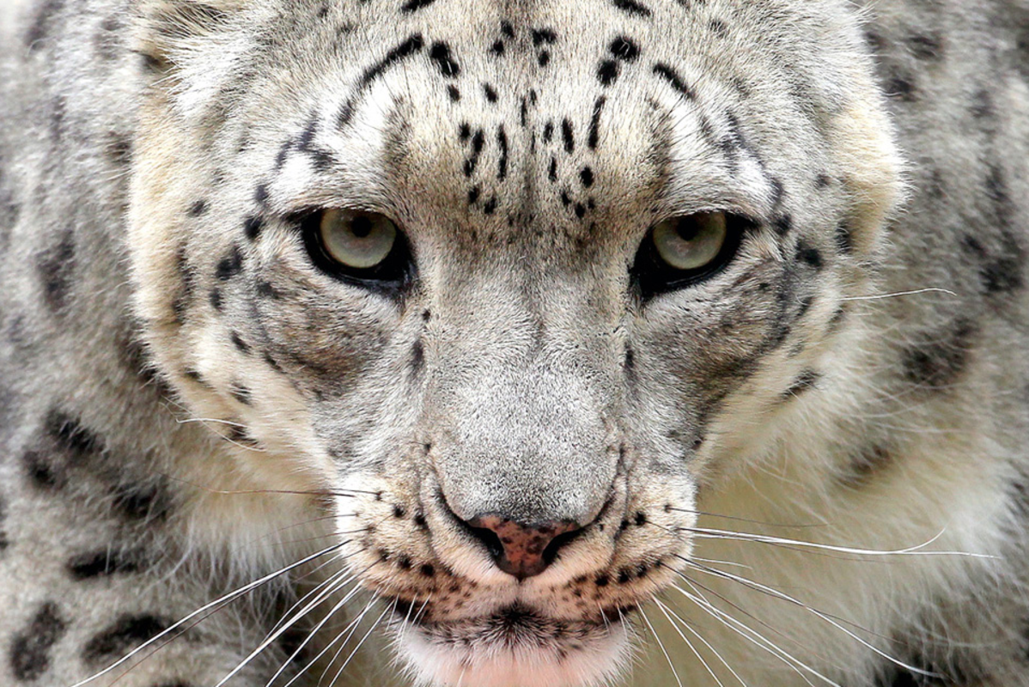
A low growl could be heard; a rumble that came from deep within the predator like a distant storm approaching.
With milky grey eyes like miniature moons, the cat began to prowl stealthily out of the tall grass…
Can you write your own description of the big cat using great adjectives? Can you describe what it is like where they live? Try and use words from the text above. You could draw a big cat when you have completed your description.
Can you use one of these words in every sentence to extend your ideas - and, because, so, but and however.

