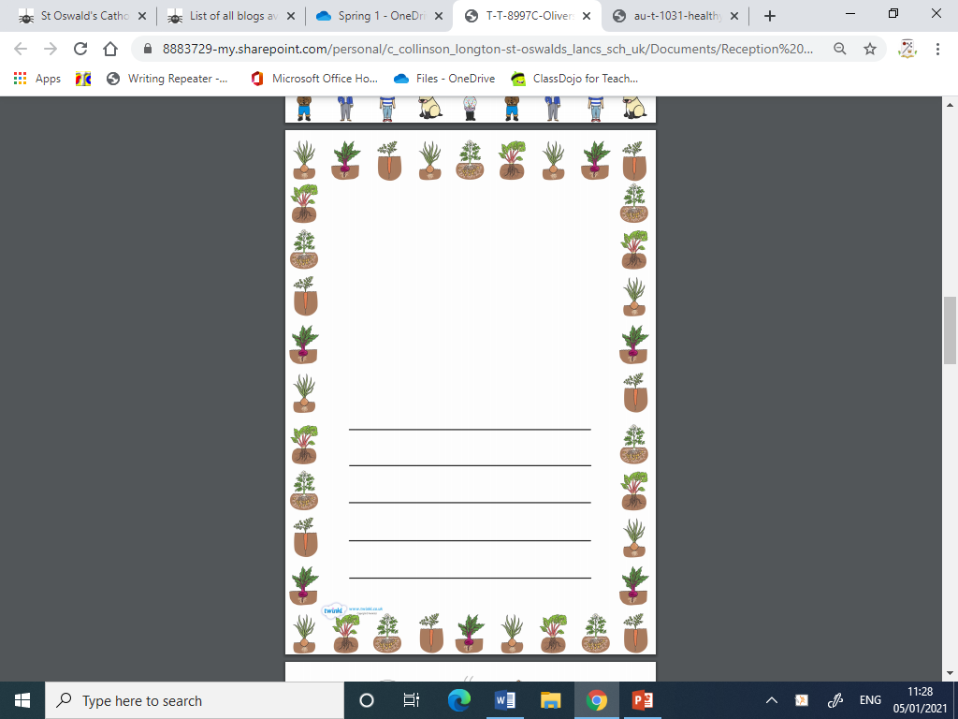

Can I write a list of vegetables? 06.01.21