Appearance

Traditionally, a werewolf is indistinguishable from an ordinary wolf apart from several features. These are: a larger body, lack of a distinct tail, human eyes and voice. When a werewolf is in human form, they have tell-tale physical traits including: meeting of both eyebrows (‘monobrow’), curved fingernails, low-set ears and a swinging stride.

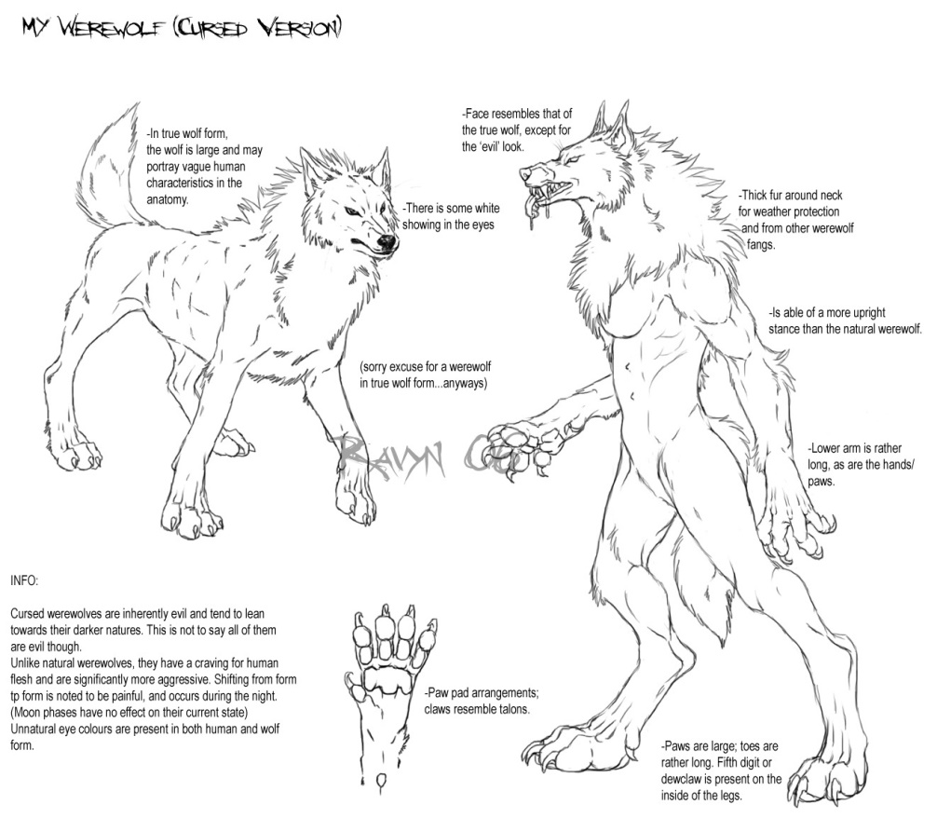

Modern culture

Even after many centuries of tales, a fascination with werewolves still exists in modern society. The most popular depiction of a werewolf on film is in the renowned movie franchise: ‘Twilight’. Another work of fiction which mentions these mythical beasts is ‘Harry Potter’. This series of books features several werewolves (including Remus Lupin). 

Werewolves

**Werewolves, also known as lycanthropes, are mythological or folkloric humans with the ability to shape-shift into a hybrid wolf-like creature. They are generally found in Europe and date from the medieval period. The legend of the werewolf developed in parallel to the belief in witches and is still evident in popular culture today.**

Shape-shifting ability

Werewolves are humans who transition into wolf-like creatures, either purposefully or after being placed under a curse. Various methods of becoming a werewolf have been reported. In folklore, most werewolves originate from being cursed or bitten by another werewolf. Historically, most werewolves transform under the light of a full moon. Some historical tales list other stranger methods of transformation, such as: rubbing the body with magic ointment, drinking rainwater out of the footprint of the animal or repeating a set spell. After returning to their human form, werewolves are usually documented as becoming weak, debilitated and undergoing painful, nervous depression.

How dangerous are they?

Often perceived as a threat throughout history, werewolves generally prey on any living thing; however they particularly target children. Werewolves attack in a variety of ways. The Scandinavian werewolf is known to possess poison-coated claws. This creature uses its gaze to paralyse its victims which enables the final blow to be delivered with devastating accuracy. Some werewolves are known to target the graves of their victims; digging up bodies to consume to satisfy their cravings.