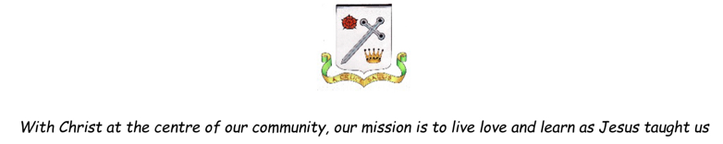

Art Progression in Key Skills

Year Group | Key Skills
Year 1 | Experiment using lines and marks, form and shape, tone and texture with a variety of media; pencils, rubbers, crayons, pastels, felt tips, charcoal, ballpoints, chalk.  Review what they and others have done and say what they think and feel about it.  Use a simple graphics package to create images and effects with lines, shapes, colours and texture  Use a variety of tools and techniques including different brush sizes and types.  Experiment with tools and techniques e.g. layering, mixing media, scrapping through.  Take simple prints i.e. mono –printing.  Cut and shape fabric using scissors/snips.  Explore sculpture with a range of malleable media.  Create images from a variety of media by folding, crumpling, tearing and overlapping papers.
Year 2 | Control the types of marks, form and shape, tones and textures made with the range of media.  Identify what they might change in their current work or develop in future work.  Use basic selection and cropping tools.  Use a variety of tools including different brush sizes and types and techniques including layering, mixing media, scrapping through.  Mix primary shades and secondary colours tones.  Design more repetitive patterns with overprinting motifs and colour.  Manipulate malleable materials for a purpose  Sort and group materials for different purposes e.g. colour texture.
Year 3 | Select and record from first hand observation, experience and imagination, and explore ideas for different purposes.  Develop ways in which l can be added to drawings using lines and marks, form and shape, tone and texture with a variety of media.  Use a graphics package to create images and effects with; lines by controlling the brush tool with increased precision.  Experiment with different effects and textures including blocking in colour, washes, thickened paint creating textural effects.  Explore mixing colours and experiment with tints and shades  Experiment with a range of collage techniques such as tearing, overlapping and layering to create images and represent textures.  Compare ideas, methods and approaches in their own and others’ work and say what they think and feel about them.
Year 4 | Adapt their work according to their views and describe how they might develop it further.  Annotate work in journal.  Question and make thoughtful observations about starting points and select ideas to use in their work.  Use and apply learned techniques to add surface detail to drawings using lines and marks, form and shape, tone and texture with a variety of media.  Experiment with colours and textures by using effects and simple filters to manipulate and create images for a purpose (digital media, printing and textiles).  Join clay adequately and construct models and experiment with surface patterns and textures.  Create different effects and textures with paint according to what they need for the task.  Mix and use tints and shades  Use collage as a means of collecting ideas and information and building a visual vocabulary.
Year 5 | Select and record from first hand observation, experience and imagination, and explore ideas for different purposes.  Compare ideas, methods and approaches in their own and others’ work and say what they think and feel about them.  Use different techniques for different purposes i.e. shading, hatching within their own work using lines, marks, tone, form and texture.  Begin to use simple perspective in their work using a single focal point and horizon.  Use a graphics package to create and manipulate new images.  Try out different media and materials and mixing appropriate colours.  Create prints with three overlays.  Plan a sculpture through drawing and explore skills in using clay including slabs, coils and slips  Use a range of media to create collages to extend work from initial ideas.
Year 6 | Question and make thoughtful observations about starting points and select ideas to use in their work.  Adapt and annotate their work according to their views and describe how they might develop it further.  Independently use and develop different techniques for different purposes using lines, marks, tone, form and texture  Begin to develop an awareness of composition, scale and proportion  Start to develop their own style using tonal contrast and mixed media  Mix and match colours to create atmosphere and light effects.  Work into prints with a range of media e.g. pens, colour pens and paints.  Experiment with a range of media to overlap and layer creating interesting colours and textures and effects  Plan a sculpture through drawing, painting and digital design and further develop skills in using clay including slabs, coils and slips  Use different techniques, colours and textures etc. when designing and making a collage.

