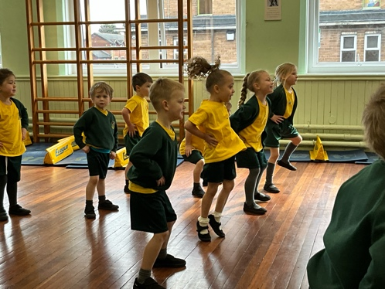

Reception being put through their paces by Freddy Fit.

**FOOTBALLERS REACH SHIELD FINAL**

**Freddy Fit Visits**

The Athletics Team after their success in the Penwortham Finals



**PE AND SPORT**

**ATHLETICS TEAM LANCASHIRE SUCCESS**

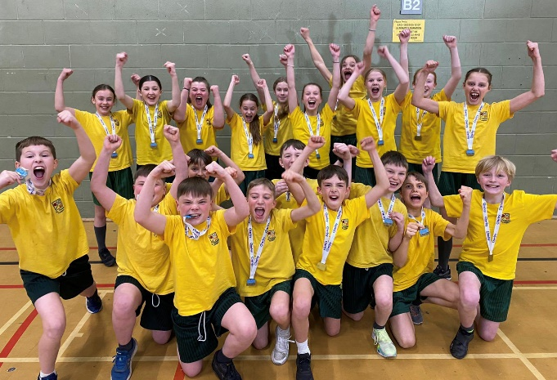

We are thrilled to announce that our school's Athletics team has won the Lancashire finals, marking the first time in our school's history that we have achieved such a feat. Mrs Cookson was overjoyed with the achievement and is so proud of everyone on the team.

The team, made up of Year 5 and Year 6 pupils, travelled to Blackpool on the 14th of March to compete against the top 14 schools in the county. Our Athletic team demonstrated excellent sportsmanship and exceptional skill throughout the competition, which proved to be an exciting and intense experience. Their hard work, dedication and commitment to training paid off, and they emerged victorious as the overall winners.

"Our school's Athletic team has set a high standard of sportsmanship and teamwork, and we are incredibly proud of their achievements. They have shown what can be accomplished with hard work and dedication," commented Mr Mears.

The team's achievement is a testament to their resilience, determination, and passion for sport. They represented our school with pride and dignity, and we couldn't be more proud of them. We would like to extend our heartfelt congratulations to the team and all involved in making this historic victory possible. Well done!



Freddy Fit recently visited our school and worked with all classes to remind us of how to stay healthy. The visit was a big hit with everyone, who enjoyed learning from Freddie's energetic and engaging approach.

Throughout the day, Freddie led fun and interactive fitness activities that got everyone moving and excited about staying active. In addition to the physical activities, Freddy also shared tips and information about healthy eating and lifestyle habits. Overall, it was an informative and enjoyable day that helped to reinforce the importance of staying fit and healthy.

‘I really enjoyed exercising and the music’ Ellie (Reception)



St. Oswald's A team recently competed in the Lancashire finals, where they qualified for the shield and reached the final. Despite a valiant effort, the team was ultimately beaten 2-1 in the final. However, the team played brilliantly and gave it their all for St. Oswald's.

Throughout the tournament, the team demonstrated excellent teamwork, communication, and sportsmanship. Their hard work and dedication paid off with a well-deserved spot in the finals, where they represented St. Oswald's with pride and determination.

Although the result was not what they had hoped for, the team should be proud of their achievement and the way they conducted themselves both on and off the pitch. Congratulations to the St. Oswald's football team on a successful season!



Issue 6 Presented by St Oswald's School Council and Year 6 Spring 2023

**THE LEARNING TIMES**

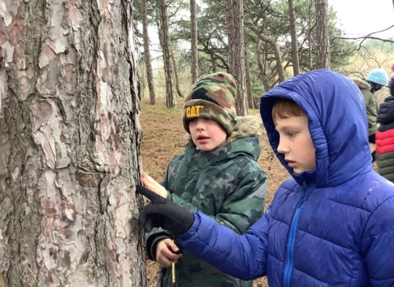

As part of their geography learning on coasts, Year 4 recently went on a field trip to Formby Beach. The class had the opportunity to explore the dunes and investigate the local area.

Throughout the day, the pupils engaged in hands-on learning activities, such as identifying different types of plants and animals that inhabit the dunes. They also learned about the formation of the dunes and how they play a crucial role in protecting the coastline from erosion. The trip was not only educational but also an enjoyable experience for everyone. They were able to connect with nature, appreciate the beauty of the beach, and learn about the importance of preserving the coastline for future generations.

‘We learned a lot about how climate change is affecting coasts’ Ava and Kate (Year 4)

Overall, it was a successful trip that left the pupils with a deeper understanding of coasts and their significance to our environment

Year 2 also had a memorable trip to Bring Yer Wellies, as part of their plants learning. On their visit, they planted some herbs and learned all about soils and what helps plants to grow.

The children represented the school wonderfully and enjoyed every minute of their outdoor learning.

**Science and Geography trips bring learning to life**

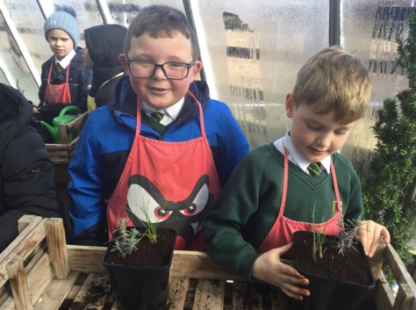

Ishan and Eli exploring trees in the area.

**World Book Day at St Oswald’s**

Louis and Bertie enjoying the planting at Bring Yer Wellies.

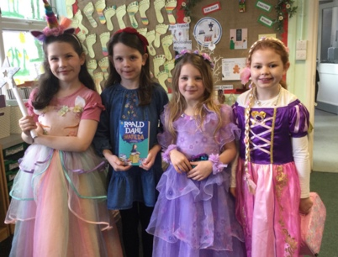

Ada-Mae, Lily, Evelyn and Elena and their brilliant costumes.

Year 1 with their books on World Book Day 2023

Our school had a fantastic time celebrating World Book Day this year. The children came to school dressed up as their favourite book characters, and it was amazing to see so many wizards, princesses, and superheroes walking around. It was a great opportunity for us to showcase our love for reading and to celebrate the joy of books.

During the day, we had some special guest readers who came to share their favourite stories with us. They brought some exciting new books that we haven't read before and we learned about new authors and illustrators. It was inspiring to see the passion they had for reading and writing, and it made us even more excited about our own reading journeys. We also had a book swap, where we could exchange books with our friends and discover new stories. It was great to see everyone getting involved and sharing their favourite books with others.

‘I enjoyed the whole day and I love my new book.’ - Agatha (Year 3)

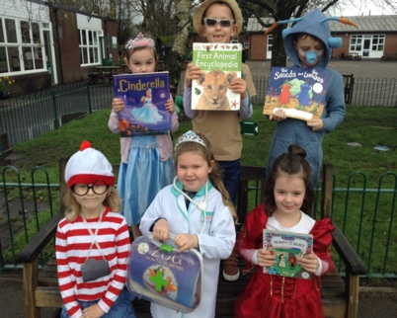

Overall, it was a fantastic day filled with fun and learning. It reminded us of the importance of reading and how it can bring people together. We can't wait to celebrate World Book Day again next year, and who knows what wonderful characters and stories we will discover!

**In this issue… Riveting Reads, Coding Club, Athletics Success, Wider Opportunities, Learning Catch-up**



**ENGINEERING AND DESIGN**

**AT ST OSWALD’S!**

**LEARNING CATCH-UP**



**RIVETING READS**

Have you ever found yourself lost in a good book? Well, that’s exactly what’s been happening in some of our classes at school!

Year 3 has been enjoying reading two amazing books: Journey to Jo’burg and Toro, Toro. These books have taken us on a journey to South Africa and Spain, where we have learned about different cultures and traditions. It has been fascinating to discover new things about the world and to experience the excitement of the characters’ adventures.

Meanwhile, Year 6 has been reading The Good Thieves, a book about a group of children who plan a heist to save their grandfather’s home. The story has been full of action and suspense, keeping us on the edge of our seats as we follow the characters’ daring plan.

‘My favourite character was Arkady because he was kind to animals’ Gabriella R (Year 6)

In Year 5, we have been enjoying the book Street Child. This is a story set in Victorian London, where we have learned about the hardships faced by children who lived on the streets during that time. We have been amazed by the bravery of the main character, Jim, who manages to survive despite all the challenges he faces.

Reading these books has been an amazing adventure. We have been transported to different places and times, and we have learned so much about the world and ourselves. We can’t wait to see what other exciting books we will read in the future!

Design and Technology has been a big hit at our school this year, with some amazing projects and learning taking place across all year groups. In Year 2, children have been learning about vehicles and have been busy making their own using wheels and axles. They have had to think about the different parts of their vehicles and how they work together to make them move.

‘I loved making the wheels work’ - Mark (Year 2)

Meanwhile, Year 3 have been exploring mechanisms and have been designing their own moving pictures. It has been impressive to see the creativity and problem-solving skills they have demonstrated.

In Year 5, children have been learning all about cams and have been creating their own toys for Year 1 to play with. They have had to think carefully about the different shapes and sizes of cams and how they can be used to create different movements.

‘We took our time and used our imaginations.’ Bella and Nora (Year 5)

Overall, DT has been a huge success at our school, with children learning new skills, developing their creativity, and having fun along the way. We can't wait to see what other amazing projects they will come up with next!

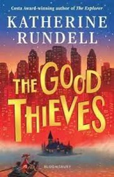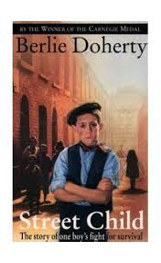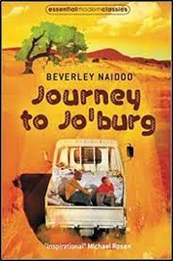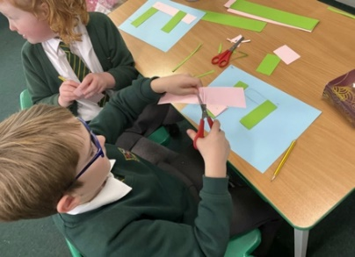

Florence and Theo finalising their mechanism designs - Year 3

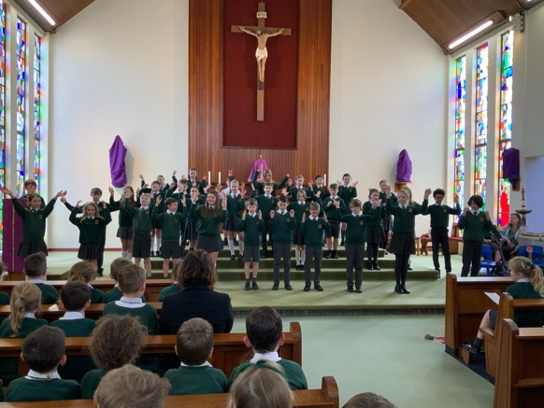

**Year 6 lead Easter Liturgy Celebration**

This Holy Week, we celebrated our Easter Liturgy with the parish in Church. It was a solemn and reflective service, as we all came together to remember the sacrifice that Jesus made for us. Year 6 led us in prayer, readings, and hymns, and their reverence and commitment were truly inspiring. The church was filled with beautiful singing throughout as they sang hymns and recited prayers. The liturgy reminded us of the importance of this holy season and the hope that Easter brings. It was a moving and meaningful experience for everyone who attended, and we are grateful to Year 6 for their leadership and dedication.

‘We used actions to tell the Easter story, I enjoyed performing in front of the whole church’ Gabriella T and Sophia M (Year 6)

Year 6 leading our Easter Liturgy in Church

**Gardening Club blooms at St Oswald’s**

**WIDER OPPORTUNITIES**

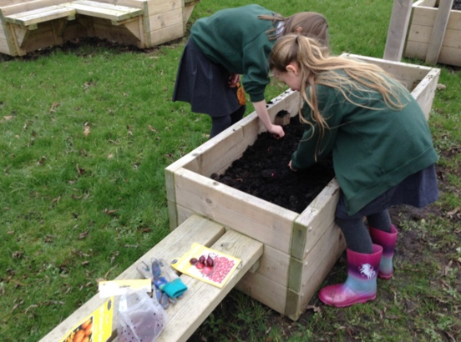

Our school has started a new gardening club, run by Mrs. Corbett, and it has been a huge success! Year 4 pupils have been taking the lead in this initiative, and they have been working hard to plant a variety of flowers, plants, and vegetables around the school grounds. It has been great to see our school grounds come to life with new colours and smells!

‘I like gardening because we get to plant lots of different seeds and watch them grow.’ Ava M (Year 4)

The gardening club has been an excellent way for pupils to learn more about nature and the environment, and it has been a fantastic opportunity for them to get their hands dirty and engage in some hands-on learning. The club has also provided a great sense of community, as pupils have been working together to tend to the plants and vegetables.

We are excited to see what the gardening club will bring in the future and how it will continue to grow and flourish.

Isla and Ava (Year 4) planting some bulbs in our new planters.





**CHICKS HATCH IN YEAR 1**

**YEAR 3 AND YEAR 4**

**CODING CLUB**

Our Year 1 class recently learned about the life cycle of chickens by hatching eight eggs in an incubator.

The pupils carefully monitored the eggs, recording their observations in a journal as the chicks developed inside. Over several days, the class excitedly watched as the eggs hatched into adorable fluffy chicks. The pupils took turns caring for the chicks, learning how to handle them gently, feed them, and provide water.

‘They were cute and cuddly’ – (Daisy Year 1)

The chicks quickly became the centre of attention in the classroom, with pupils taking turns holding and playing with them. The experience provided a valuable hands-on learning opportunity, teaching the pupils about responsibility, animal care, and the wonders of nature.

This term our school has been running a coding club, which was run by the year 3 and 4 Digital Leaders. The club was a great success and provided pupils with the opportunity to use the Code.org platform to design their own Minecraft games.

The coding club took place every Friday at lunchtime and was open to year 3 and year 4 pupils. The pupils involved were able to develop their coding and programming skills, whilst working collaboratively to design their games. This was a fantastic opportunity for them to further develop their digital skills and learn about the world of coding.

‘I am enjoying Coding Club because it is fun and challenging’ Imogen (Year 3)

The digital leaders were instrumental in facilitating the club and provided excellent guidance and support to all involved. They created a positive and supportive environment, which allowed the pupils to feel confident and empowered in their learning. The club proved to be a huge success, and we are looking forward to the next one!



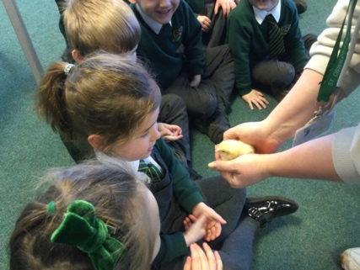

Noa in Reception meeting one of our new chicks.