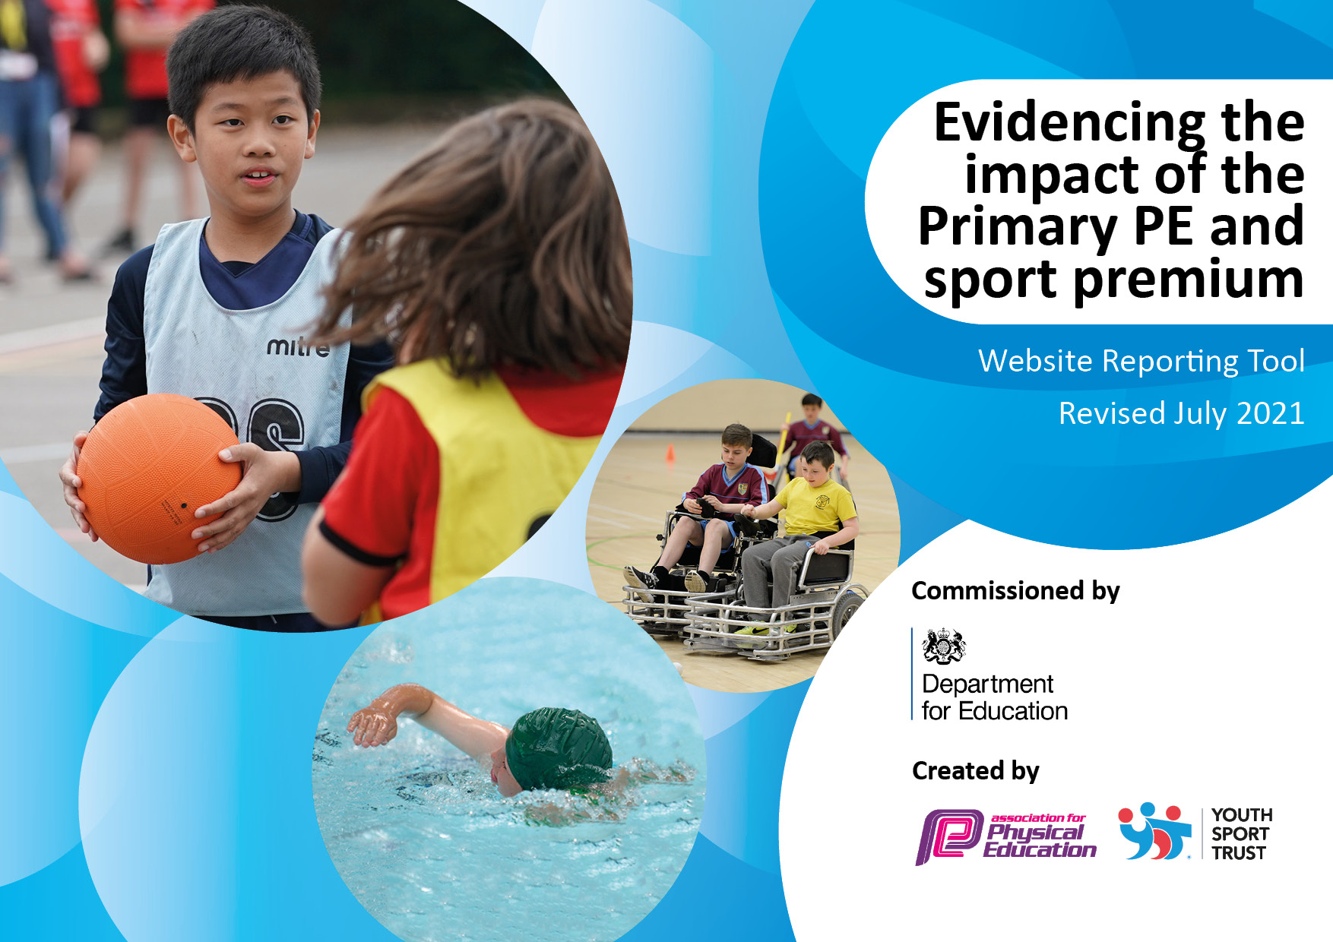

It is important that your grant is used effectively and based on school need. The Education Inspection Framework makes clear there will be a focus on ‘whether leaders and those responsible for governors all understand their respective roles and perform these in a way that enhances the effectiveness of the school’.

Under the Quality of Education Ofsted inspectors consider:
Intent - Curriculum design, coverage and appropriateness
Implementation - Curriculum delivery, Teaching (pedagogy) and Assessment
Impact - Attainment and progress

To assist schools with common transferable language this template has been developed to utilise the same three headings which should make your plans easily transferable between working documents.

Schools must use the funding to make additional and sustainable improvements to the quality of Physical Education, School Sport and Physical Activity (PESSPA) they offer. This means that you should use the Primary PE and sport premium to:

- Develop or add to the PESSPA activities that your school already offer
- Build capacity and capability within the school to ensure that improvements made now will benefit pupils joining the school in future years
- The Primary PE and sport premium should not be used to fund capital spend projects; the school’s budget should fund these.

Pleasevisitgov.ukfortherevisedDfEguidanceincludingthe5keyindicatorsacrosswhichschoolsshoulddemonstrate animprovement.Thisdocumentwillhelpyoutoreviewyourprovisionandtoreportyourspend.DfEencouragesschools to use this template as an effective way of meeting the reporting requirements of the Primary PE and sport premium.

We recommend you start by reflecting on the impact of current provision and reviewing the previous spend.

Schools are required to publish details of how they spend this funding, including any under-spend from 2019/2020, as well as on the impact it has on pupils’ PE and sport participation and attainment. All funding must be spent by 31st July 2022.
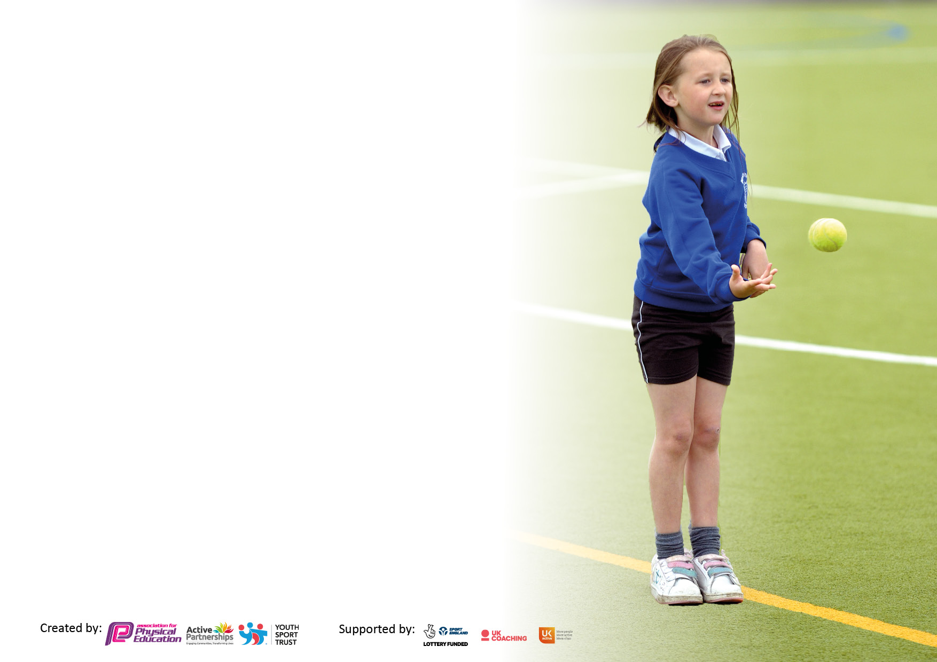
We recommend regularly updating the table and publishing it on your website throughout the year. This evidences your ongoing self-evaluation of how you are using the funding to secure maximum, sustainable impact. Final copy must be posted on your website by the end of the academic year and no later than the 31st July 2021. To see an example of how to complete the table please click HERE.

Details with regard to funding
Please complete the table below.

Total amount carried over from 2019/20 | £0
Total amount allocated for 2020/21 | £18243
How much (if any) do you intend to carry over from this total fund into 2021/22? | £0
Total amount allocated for 2021/22 | £18000
Total amount of funding for 2021/22. To be spent and reported on by 31st July 2022. | £18000
Swimming Data
Please report on your Swimming Data below.

Meeting national curriculum requirements for swimming and water safety.

N.B. Complete this section to your best ability. For example you might have practised safe self-rescue techniques on dry land which you can then transfer to the pool when school swimming restarts.
Due to exceptional circumstances priority should be given to ensuring that pupils can perform safe self rescue even if they do not fully meet the first two requirements of the NC programme of study
What percentage of your current Year 6 cohort swim competently, confidently and proficiently over a distance of at least 25 metres?  N.B. Even though your pupils may swim in another year please report on their attainment on leaving primary school at the end of the summer term 2020.  Please see note above | 100%
What percentage of your current Year 6 cohort use a range of strokes effectively [for example, front crawl, backstroke and breaststroke]?  Please see note above | 97%
What percentage of your current Year 6 cohort perform safe self-rescue in different water-based situations? | 97%
Schools can choose to use the Primary PE and sport premium to provide additional provision for swimming but this must be for activity over and above the national curriculum requirements. Have you used it in this way? | No

Action Plan and Budget Tracking
Capture your intended annual spend against the 5 key indicators. Clarify the success criteria and evidence of impact that you intend to measure to evaluate for pupils today and for the future.

Academic Year: 2021/22 | Total fund allocated: £18000 | Date Updated: 15.07.22
Key indicator 1: The engagement of all pupils in regular physical activity – Chief Medical Officers guidelines recommend that primary school pupils undertake at least 30 minutes of physical activity a day in school |  |  |  | Percentage of total allocation:
 |  |  |  | 1% = £200
Intent | Implementation |  | Impact
Your school focus should be clear what you want the pupils to know and be able to do and about  what they need to learn and to  consolidate through practice: | Make sure your actions to achieve are linked to your intentions: | Funding allocated: | Evidence of impact: what do pupils now know and what can they now do? What has changed?: | Sustainability and suggested next steps:
To embed the daily mile within the school culture (classes will complete a mile a day with a weekly award – Daily Miler of the Week).  ‘Mini Coaches’ to be conducted by Year 6 leaders who will support infants with various physical activities. These will include all children (those who are less physically active and those with SEN). | Create a timetable of when the yard is available for each class to complete their daily mile. Monitor this through discussions with the staff and pupils.  PE lead to train the Year 6 leaders on how to deliver these sessions with the children. Year 6 teacher to be present to monitor the development and behaviour of both the leaders and infants. | £0  £200 (in-house training) with money is spent on equipment. Training is free. | This regular activity has helped to achieve the 60 minutes of activity a day. The children comment on being physically more fit, engaged in lessons better and having more stamina.  The infants have found this to be very fun and really enjoyed being taught by Year 6. Over time, the leaders created new games, focusing on what the infants needed to improve on in their fundamental abilities. | The culture is embedded. Now we are to work on creating further awards to keep the encouragement of pupils to push themselves.  Due to the success, next year we will pay for South Ribble training of a welfare staff member and Year 6 pupils to lead future activities. This should lead to more children having access to this great resource.
Key indicator 2: The profile of PESSPA being raised across the school as a tool for whole school improvement |  |  |  | Percentage of total allocation:
 |  |  |  | 45% = £8200
Intent | Implementation |  | Impact
Your school focus should be clear what you want the pupils to know and be able to do and about  what they need to learn and to  consolidate through practice: | Make sure your actions to achieve are linked to your intentions: | Funding allocated: | Evidence of impact: what do pupils now know and what can they now do? What has changed?: | Sustainability and suggested next steps:
As we move towards our forest school award, outdoor learning has been a huge focus for our school. We intend to use some of the Sport Premium to fund a project that will raise the profile of PESSPA further.  To create a new and improved ‘Tough Kidder’ event to promote PESSPA and raise money for the school whilst working alongside the PTFA. | To design and build a new outdoor learning environment for ‘forest school’ equipment storage and a meeting place.  To have a meeting with the PTFA regarding the event. To buy new equipment to enhance the event further. | £8000  £200 | This new resource has allowed more equipment to be stored for easy access. We are currently in the process of becoming a forest school so this year we have conducted more outdoor learning, with the children learning new skills and character values – resilience, problem solving and teamwork.  The event was a success, and focused on including everyone (from Reception to Year 6) in school to keep fit and active. | We are in the process of training staff to be fully qualified forest school leaders. This will enable us to use the new equipment and new outdoor areas to its full potential.  The event is a hit with our children and staff with the Year 6 leading and helping to organise the event. We aim to continue this tradition.

Key indicator 3: Increased confidence, knowledge and skills of all staff in teaching PE and sport |  |  |  | Percentage of total allocation:
 |  |  |  | 44% = £7950
Intent | Implementation |  | Impact
Your school focus should be clear | Make sure your actions to | Funding | Evidence of impact: what do | Sustainability and suggested
what you want the pupils to know | achieve are linked to your | allocated: | pupils now know and what | next steps:
and be able to do and about | intentions: |  | can they now do? What has
what they need to learn and to |  |  | changed?:
consolidate through practice:
To enable the PE Passport app to be used well by all teachers in every year group.  To fully utilise the electronic assessment in the PE Passport app that will help track all children throughout their school life.  To use our Sports Coach to work alongside teachers in Reception and Key Stage 2 to deliver high quality lessons that focuses on inclusion. | Training by Lancashire PE to the PE lead on how the app can be used to effectively plan sequences of lessons that build on prior knowledge.  Training by Lancashire PE to the PE lead on how assessment can promote the learning of children. PE lead to give staff training on how each year group can easily assess children weekly that can be used to track children throughout their primary life.  PE lead to train up the Sports Coach on how the app can be used to improve the teaching and learning of each year group. To also train the Sports Coach to assess the pupils accurately on a weekly basis using the PE Passport app. | £350  £0 (the amount above covers the same training)  £7600 | The staff have commented on how easy the app is and how their lessons are more progressive.  The children are beginning to use the correct PE vocabulary to explain how they have acquired the skills needed to apply them in different situations.  Teachers have become used to the assessment of PE and how it can benefit the learning.  The children’s assessments have been used to plan well differentiated lessons that includes all.  Teachers are becoming more confident in how they plan progressions of lessons and how they incorporate the Sports Coach within the weekly PE lesson.  Sports Coach has become more effective in planning and assessing lessons which benefit the children in future lessons. | To improve the vocabulary of how the children evaluate and improve their knowledge and skills of PE.  To also create a seamless transition from end of KS1 to Year 3, focussing on fundamental skills.  To continue the assessment of PE in every area to gain a specific view of what area each child needs to work on in their next unit – this should help close learning gaps).  To sustain the high quality PE lessons through South Ribble CPD twilight sessions.
Key indicator 4: Broader experience of a range of sports and activities offered to all pupils |  |  |  | Percentage of total allocation:
 |  |  |  | 3% = 450
Intent | Implementation |  | Impact
Your school focus should be clear | Make sure your actions to | Funding | Evidence of impact: what do | Sustainability and suggested
what you want the pupils to know | achieve are linked to your | allocated: | pupils now know and what | next steps:
and be able to do and about | intentions: |  | can they now do? What has
what they need to learn and to |  |  | changed?:
consolidate through practice:
To increase our offer of a wide range of sports within each year group.  To increase the amount of sports clubs we offer to our children and the number of children who attend. | To use the PE Passport app to plan the whole curriculum so every area of activity is covered in each year group. To plan in extra invasion games (handball, rugby, hockey, netball, orienteering, dodgeball) so the children can apply their skills within a range of sports.  To plan out the year of extra sport clubs, during lunch time and after school.  Then to organise staff members to take charge of the clubs leading to an inter competition. To update our sport equipment (to keep the quality high) and to buy new hockey sticks to enhance our offer of hockey teaching. | £0  £450 | Children have been learning new sports and applying the invasion skills really well to each one. The inclusion of new sports has led to more competitions this year, especially dodgeball, which St Oswald’s won.  Attendance of clubs, especially at lunch time, is very high. Across the year, 100% of pupils have attended sport clubs at lunch time (Years 1 – 6), with 76% for after school clubs in Year 5 and 6. | To continue with new and updated equipment for all sports. To use South Ribble’s offer of Yoga and Mindfulness course for Key Stage 2.  To increase the participation of sport clubs even further, across Key Stage 2.  To start a Key Stage 1 after school sports club.

Key indicator 5: Increased participation in competitive sport |  |  |  | Percentage of total allocation:
 |  |  |  | 7% = 1200
Intent | Implementation |  | Impact
Your school focus should be clear | Make sure your actions to | Funding | Evidence of impact: what do | Sustainability and suggested
what you want the pupils to know | achieve are linked to your | allocated: | pupils now know and what | next steps:
and be able to do and about | intentions: |  | can they now do? What has
what they need to learn and to |  |  | changed?:
consolidate through practice:
To continue to increase the intra competitions within each year group.  To plan and execute more inter competitions and events with the help of South Ribble and Hutton Grammer.  To once again achieve our 100% participation of all children having competed in an inter competition by the end of Year 6. | Staff training by PE lead on how to increase intra competitions. Each unit of work to be completed with an intra competition, which includes a winner or winning team.  To map out the year with South Ribble and Hutton and keep all dates in the calendar.  To create a calendar of events throughout the year.  Then to work with Year 5 and 6 to promote the competitions and set up sports clubs for them to join. | £0  £1200  £0 | Children now understand how mini competitions work and how to apply their skills to them. They have also learnt character values, especially when winning or losing.  All competitions were successful. The children and staff enjoyed them with St Oswald’s coming in the top 3 in all, and winning 4 out of 8.  100% of children in Year 6 competed in an inter competition this year, with over 70% taking part in 2 or more. | Intra competitions within each year group are easy to sustain. The next task will be to include intra competitions for other sports (dodgeball, orienteering, table tennis).  To plan new inter competitions with South Ribble and extend the current offer.  With new competitions being planned for next year, we are to increase the offer out to Years 5 and 4.

Signed off by
Head Teacher: | Mrs B. Wood
Date: | 15.07.22
Subject Leader: | Mr J. Mears
Date: | 15.07.22
Governor: | Mr Mainey
Date: | 15.07.22

