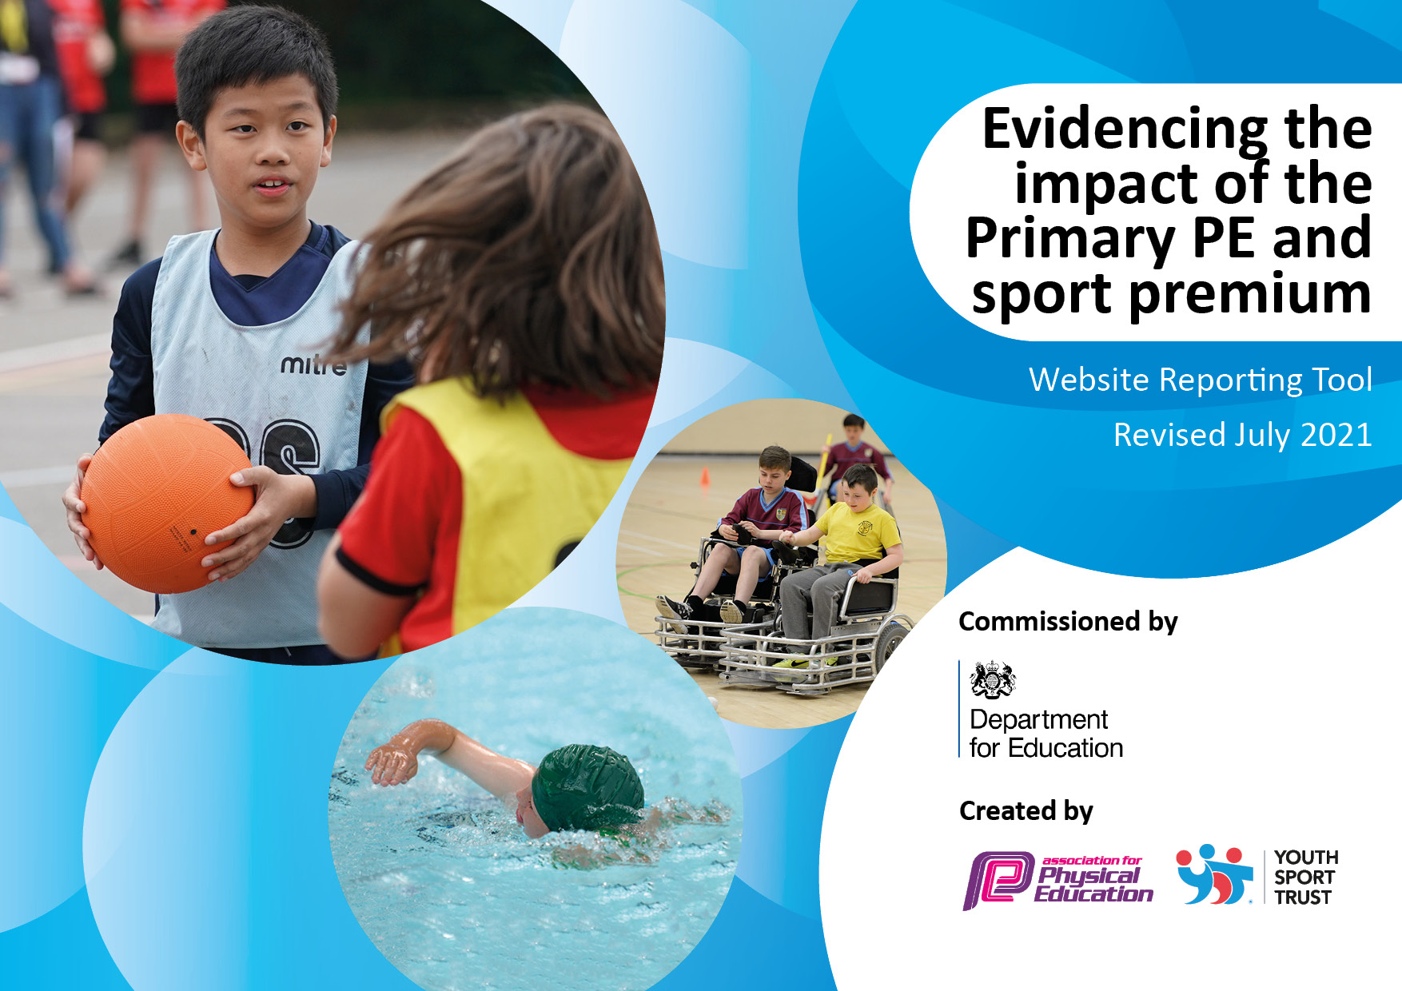
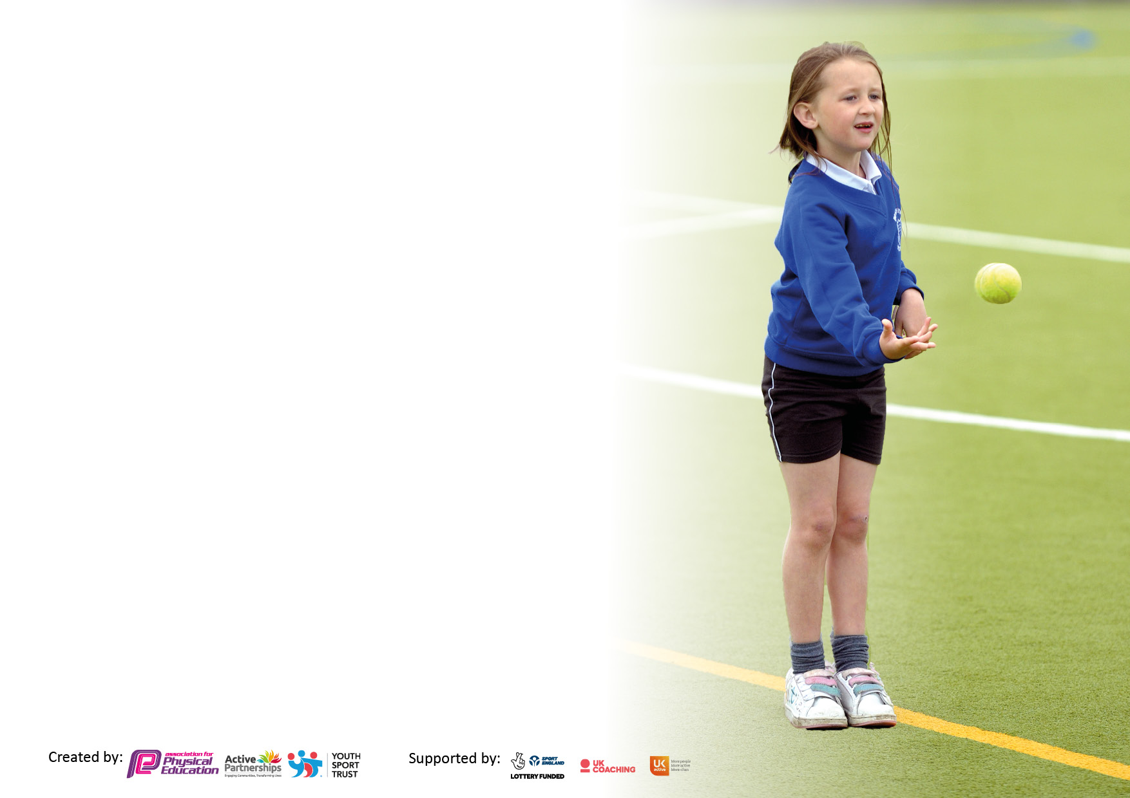

It is important that your grant is used effectively and based on school need. The Education Inspection Framework makes clear there will be a focus on ‘whether leaders and those responsible for governors all understand their respective roles and perform these in a way that enhances the effectiveness of the school’.

Under the Quality of Education Ofsted inspectors consider:
Intent - Curriculum design, coverage and appropriateness
Implementation - Curriculum delivery, Teaching (pedagogy) and Assessment
Impact - Attainment and progress

To assist schools with common transferable language this template has been developed to utilise the same three headings which should make your plans easily transferable between working documents.

Schools must use the funding to make additional and sustainable improvements to the quality of Physical Education, School Sport and Physical Activity (PESSPA) they offer. This means that you should use the Primary PE and sport premium to:

- Develop or add to the PESSPA activities that your school already offer
- Build capacity and capability within the school to ensure that improvements made now will benefit pupils joining the school in future years
- The Primary PE and sport premium should not be used to fund capital spend projects; the school’s budget should fund these.

Pleasevisitgov.ukfortherevisedDfEguidanceincludingthe5keyindicatorsacrosswhichschoolsshoulddemonstrate animprovement.Thisdocumentwillhelpyoutoreviewyourprovisionandtoreportyourspend.DfEencouragesschools to use this template as an effective way of meeting the reporting requirements of the Primary PE and sport premium.

We recommend you start by reflecting on the impact of current provision and reviewing the previous spend.

Schools are required to publish details of how they spend this funding, including any under-spend from 2019/2020, as well as on the impact it has on pupils’ PE and sport participation and attainment. All funding must be spent by 31st July 2022.

We recommend regularly updating the table and publishing it on your website throughout the year. This evidences your ongoing self-evaluation of how you are using the funding to secure maximum, sustainable impact. Final copy must be posted on your website by the end of the academic year and no later than the 31st July 2021. To see an example of how to complete the table please click HERE.

Details with regard to funding
Please complete the table below.

Total amount carried over from 2019/20 | £0
Total amount allocated for 2020/21 | £18 000
How much (if any) do you intend to carry over from this total fund into 2021/22? | £3 000
Total amount allocated for 2021/22 | £18 060
Total amount of funding for 2021/22. To be spent and reported on by 31st July 2022. | £21 060
Swimming Data
Please report on your Swimming Data below.

Meeting national curriculum requirements for swimming and water safety.

N.B. Complete this section to your best ability. For example you might have practised safe self-rescue techniques on dry land which you can then transfer to the pool when school swimming restarts.
Due to exceptional circumstances priority should be given to ensuring that pupils can perform safe self rescue even if they do not fully meet the first two requirements of the NC programme of study
What percentage of your current Year 6 cohort swim competently, confidently and proficiently over a distance of at least 25 metres?  N.B. Even though your pupils may swim in another year please report on their attainment on leaving primary school at the end of the summer term 2020.  Please see note above | 100%
What percentage of your current Year 6 cohort use a range of strokes effectively [for example, front crawl, backstroke and breaststroke]?  Please see note above | 93%
What percentage of your current Year 6 cohort perform safe self-rescue in different water-based situations? | 87%
Schools can choose to use the Primary PE and sport premium to provide additional provision for swimming but this must be for activity over and above the national curriculum requirements. Have you used it in this way? | No

Action Plan and Budget Tracking
Capture your intended annual spend against the 5 key indicators. Clarify the success criteria and evidence of impact that you intend to measure to evaluate for pupils today and for the future.

Academic Year: 2020/21 | Total fund allocated: £600 | Date Updated: 17.07.21
Key indicator 1: The engagement of all pupils in regular physical activity – Chief Medical Officers guidelines recommend that primary school pupils undertake at least 30 minutes of physical activity a day in school |  |  |  | Percentage of total allocation:
 |  |  |  | 3%
Intent | Implementation |  | Impact
Your school focus should be clear what you want the pupils to know and be able to do and about  what they need to learn and to  consolidate through practice: | Make sure your actions to achieve are linked to your intentions: | Funding allocated: | Evidence of impact: what do pupils now know and what can they now do? What has  changed?: | Sustainability and suggested next steps:
For the daily mile to be completed more regularly.  More active play for all year groups | Each class to have a fixed timetable of when to complete their daily mile  To have a weekly ‘Daily Miler’ of the week to be announced in school during Golden Assembly.  With less mixing due to COVID, we have implemented groups of children to take part in active play for intervention groups outside. | £0  £600 | Pupils have stated that the daily mile is a great break from the working day and helps to reset their mind.  All children highlighted with fundamentals lacking, improved | To embed the daily mile within the school culture (completed every day and with awards weekly).  To start ‘Mini Coaches’ initiative with Year 6 as leaders.
Key indicator 2: The profile of PESSPA being raised across the school as a tool for whole school improvement |  |  |  | Percentage of total allocation:
 |  |  |  | 41%
Intent | Implementation |  | Impact
Your school focus should be clear what you want the pupils to know and be able to do and about  what they need to learn and to  consolidate through practice: | Make sure your actions to achieve are linked to your intentions: | Funding allocated: | Evidence of impact: what do pupils now know and what can they now do? What has changed?: | Sustainability and suggested next steps:
More outdoor learning for links across the curriculum.  A new ‘Tough Kidder’ event linked to wellbeing and physical health to involve the whole school  To create a garden area to develop physical activity, whilst building the outdoor skills of gardening. | Each class are given outdoor learning links to topics that are being taught throughout the year.  To continue following guidance, but hopeful we can include the whole school for the event.  Organise builders to design an area for gardening in which the whole school can use. | £0  £300  £7000 | Children had gained new skills with shelter building and rope tying. The characteristics of resilience, problem solving and teamwork were able to be transferred effectively into the classroom.  The event was another huge success with the Year 6 leaders supporting the school in completing the course.  Children have been given more opportunities for outdoor learning, with gardening skills being the main focus. | New outdoor learning leader to begin next academic year.  To update PSHE curriculum to link with physical health and wellbeing  To continue this event with the added bonus of inviting the parents to spectate.  This has been one of our main projects to continue to improve the school’s provisions. Next year, we will focus on improving our outdoor learning provision, ready to complete our forest school training.

Key indicator 3: Increased confidence, knowledge and skills of all staff in teaching PE and sport |  |  |  | Percentage of total allocation:
 |  |  |  | 27%
Intent | Implementation |  | Impact
Your school focus should be clear | Make sure your actions to | Funding | Evidence of impact: what do | Sustainability and suggested
what you want the pupils to know | achieve are linked to your | allocated: | pupils now know and what | next steps:
and be able to do and about | intentions: |  | can they now do? What has
what they need to learn and to |  |  | changed?:
consolidate through practice:
To have clear skill progressions in all year groups  To create interventions that help those behind age related expectations  Embed the new KS1 and KS2 scheme of work  Sport Coach to work alongside teachers in Reception and KS2 to delivering high quality PE sessions. | Introduction of the PE skills progression from Reception to Year 6.  Baseline assessment by Reception to indicate who to provide intervention for.  Use the school’s Sports Coach to deliver interventions in the afternoons.  New Scheme of Work (SOW) for the whole school is introduced to all staff.  Training is given on how to use the new resources.  Support is given throughout the year to continue good practice.  Sports Coach to plan, prepare and assess lesson alongside the teachers for Reception, Year 3, Year 4, Year 5 and Year 6 | £0  £600  £500  £3800 | Skills progression has given a clearer understanding of what level children should achieve at age related expectations. Teachers are now equipped to better differentiate.  Those targeted improved greatly in their fundamental skills.  Teachers are more confident with the SOW and praise how useful it is to help teach the skills in detail.  Children are given more opportunities to develop their skills in all areas.  More areas of activity have been covered this year with the help of the Sports Coach | To develop the assessment of PE using the PE Passport app with detailed outcomes for each child.  To target all children in the Infants to see if any fundamental interventions are needed.  To fully utilise the electronic assessment in the PE Passport app that will track all children throughout their school life.
Key indicator 4: Broader experience of a range of sports and activities offered to all pupils |  |  |  | Percentage of total allocation:
 |  |  |  | 10
Intent | Implementation |  | Impact
Your school focus should be clear | Make sure your actions to | Funding | Evidence of impact: what do | Sustainability and suggested
what you want the pupils to know | achieve are linked to your | allocated: | pupils now know and what | next steps:
and be able to do and about | intentions: |  | can they now do? What has
what they need to learn and to |  |  | changed?:
consolidate through practice:
For children to be offered a wide range of sports within the PE curriculum.  For more sport clubs to commence (depending on guidance from the government) during lunch time and after school. | To assess the current provision that our PE curriculum provides.  To see where gaps could be filled (invasion games / net, wall) to see if new sports and equipment could be implemented.  To create a timetable for the sports coach to work across the school during lunch times.  To start after school clubs with football, netball, hockey again. | £400  £1400 | New equipment has been bought – handball, dodgeball, table tennis and tennis.  The children have learnt new skills and sports.  The sporting clubs were successful until the second lockdown (Jan – Feb). Children’s mental health improved with many wanting more activities. | To continue to include these sports within their specific areas of the curriculum. To also take part in these sports for next year’s intra competitions.  With the guidance saying that we can open the school to mixing, a plan for more sports and activities will commence for 2021-22

Key indicator 5: Increased participation in competitive sport |  |  |  | Percentage of total allocation:
 |  |  |  | 2%
Intent | Implementation |  | Impact
Your school focus should be clear | Make sure your actions to | Funding | Evidence of impact: what do | Sustainability and suggested
what you want the pupils to know | achieve are linked to your | allocated: | pupils now know and what | next steps:
and be able to do and about | intentions: |  | can they now do? What has
what they need to learn and to |  |  | changed?:
consolidate through practice:
To engage 100% of children in intra-school competitions.  To engage the children with more competitions than previous year (due to COVID). | With mixing being limited, we are to timetable intra-school competitions throughout the year for all children to participate. This will include a range of sports, inclusive to all.  To once again work with South Ribble to compete in more activities. | £0  £400 | The children had an intra competition at the end of each PE unit. They could demonstrate all the skills learnt whilst playing competitively with their peers.  Pupils have had many opportunities to apply their skills in different competitive situations.  We had a great start to the year taking part in more activities but due to the second lockdown, we continued with the intra-school competitions instead, alongside new virtual competitions. | The success of the intra-school competitions will continue next year, for every age group.  The guidance is saying that more competitions will begin again next year so we are planning to work with Hutton Grammar, All Hallows’ and South Ribble to bring back many competitions.

Signed off by
Head Teacher: | Mrs B. Wood
Date: | 16.07.21
Subject Leader: | Mr J. Mears
Date: | 16.07.21
Governor: | Mr M. Mainey
Date: | 16.07.21

