Wednesday 3rd March 2021
Can I write a postcard as a character from the story?
Starter
Today, we are going to start our new book which follows on from The Day the Crayons Quit.
Take a look at the front cover:
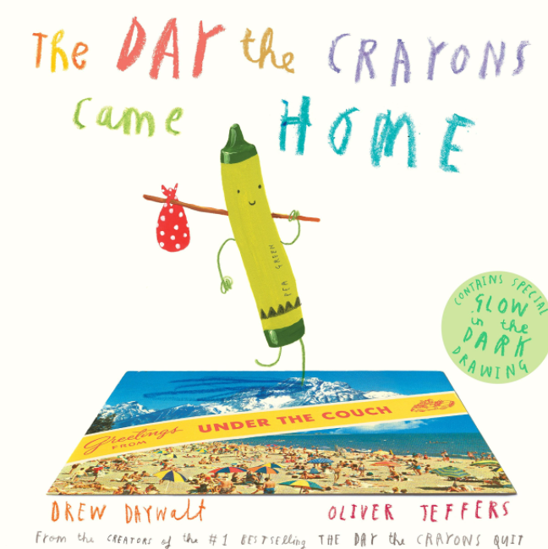
What do you think the story might be about?
How can you tell from the pictures?
What information does the title of the story give you?
How did the crayons get home? Do they want to come home?
Read and enjoy The Day the Crayons Came Home by Drew Daywalt and illustrated by Oliver Jeffers. You can view the story on PowerPoint attached to the end of this post or you can use the following link to listen to the story.
Please read up to Glow in the Dark Crayon
Main Task
Imagine you are another item in Duncan’s pencil case, e.g. a ruler, pencil sharpener, highlighter pen, biro.
Write a postcard to Duncan to add to the collection sent to him.
Start by thinking about the features of a postcard.
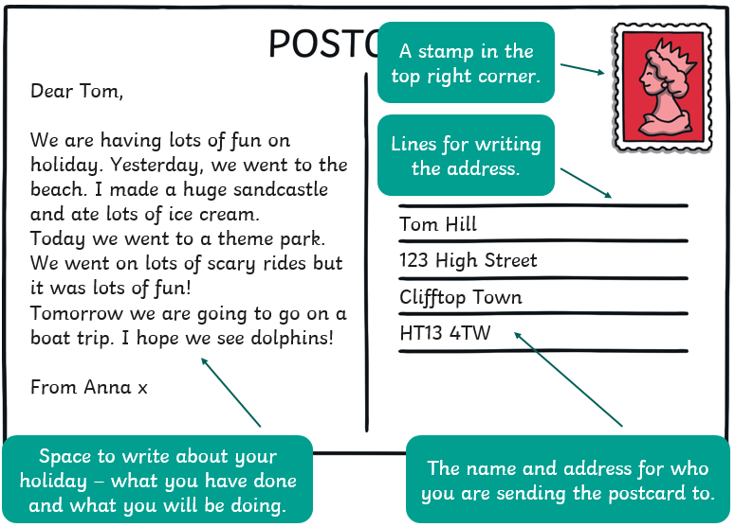
Remember to include time words like today, yesterday and tomorrow.
Today we are going to travel to the jungle
Yesterday we went to the beach.
Tomorrow we will go on a boat trip.
You can use a handy word mat (attached to the blog) to support you when writing postcards. They are grouped into a range of themes, each area gives key vocabulary suited to different locations as well as key phrases to use during postcard writing at the top of each mat as a reminder.
Think about: What job did you originally have in the pencil case? Did you enjoy your job? Might you have any memorable stories to remind Duncan of? What has happened to you since you were last with Duncan? E.g. Have you been travelling to any exciting places? What might you like to ask Duncan now? As if you are the ruler, pencil sharpener, highlighter etc. write your postcard to Duncan.
Rehearse each sentence out loud before you write to check it makes sense.
Keep reading your work as you write to check for spelling and punctuation too.
Send your finished postcard to us on Seesaw. We could end up with a class set of postcards from various pencil case items!
Success criteria
- I have written from the character’s viewpoint
- I have detailed key events from the day
- I have used time words
- Produce beautiful handwriting with lead-ins to every letter
- Double check for punctuation and spelling errors

