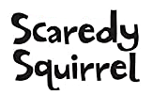

Can I describe what happened to Scaredy Squirrel when he spotted all the Racoons?
Can I use these words in my writing?

First… Next… After that... Then… Finally…

