Hilaire Belloc

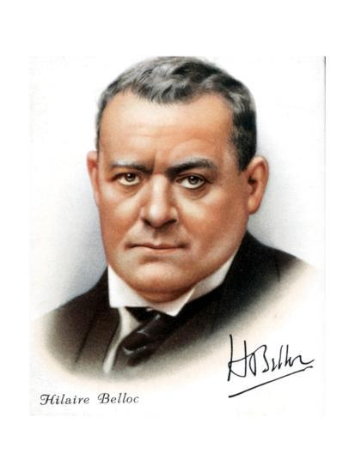 | Born: 1870, La Celle-Saint-Cloud, France  Died: 1953, Guildford, England  Writing: Essays, Travel-Writing, Poetry, History  Matilda told such dreadful lies,  It made one gasp and stretch one's eyes;  Her aunt, who, from her earliest youth,  Had kept a strict regard for truth,  Attempted to believe Matilda:  The effort very nearly killed her…

