Tuesday 2nd March 2021
Can I write a persuasive letter?
Starter
What is a persuasive writing?
Where might we see persuasive writing?
Here is a reminder of the letter we received in school yesterday:
Dear Mr Ingram and Miss Bennison,
It’s me, Glue Stick. I am writing to tell you that I have decided to quit my job as your class Glue Stick. First of all, I would like to say that I love being the class glue stick. It’s great to see all the children using me to stick in their precious work. Also, I love it when I am used in Art. Art is my favourite subject. I wish to congratulate Year 2 for a successful “glueing in career” so far, you are all doing an amazing job. However, some children in your class leave my lid off and I am DYING! I go all dry and horrible. Furthermore, there are some children who use too much of me. One child the other week used half of me on one piece of paper. Can you believe that? I need a break! Try to use me more sparingly and remember to put my lid on!
Your dry, horrible and soon-to-be ex-friend,
Glue Stick
Main Task
Look back through yesterday’s plan.
Today, we will be pretending we are a stationery item and we are going to write ‘as’ that character, using the first person.
What is first person?
You need to use language such as ‘my’, ‘I’ and ‘me’ when writing your letter. You should also remember to use words such as ‘you’ and ‘your’ when referring to the owner of the item.
It’s important that we try and use some persuasive language in our letter.
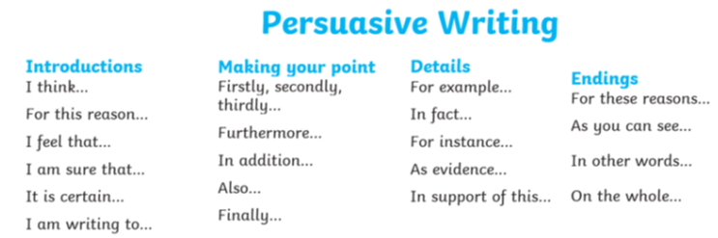

Here is an opener you could use to get you started:
Dear Mr Ingram and Miss Bennison,
I am writing to tell you that I have decided to quit my job as your _________.

If you are struggling you could use the template below for additional support:
Dear _[teacher]_,
I am writing to tell you that I have decided to quit my job as your _[stationary]_. I love _[opinion/action relevant to stationary]_ but now I am _[feeling/emotion]_. I feel like this because _[reason for feeling/emotion]_. I would be really happy if _[resolution to problem]_. I look forward to reading your response,
_[stationary]_.
Success criteria
- Think about the item you have chose
- Think about what it is complaining about
- Use persuasive and descriptive language
- Use your plan to help you
- Produce beautiful handwriting with lead-ins to every letter
- Double check for punctuation and spelling errors

