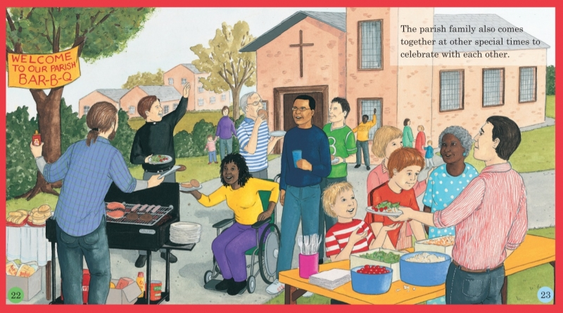
- Who is at these gatherings?
- What are the members of the parish family doing?
- Why are they happy?
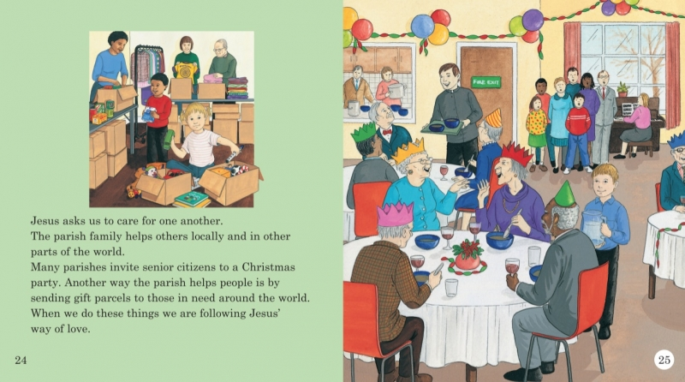
- What is good about coming together as a parish family?

