Monday 1st March 2021
Can I plan a persuasive letter?
Starter
Myself and Miss Bennison walked into the classroom this morning and found a letter next to a glue stick. Take a look at the front of the letter.
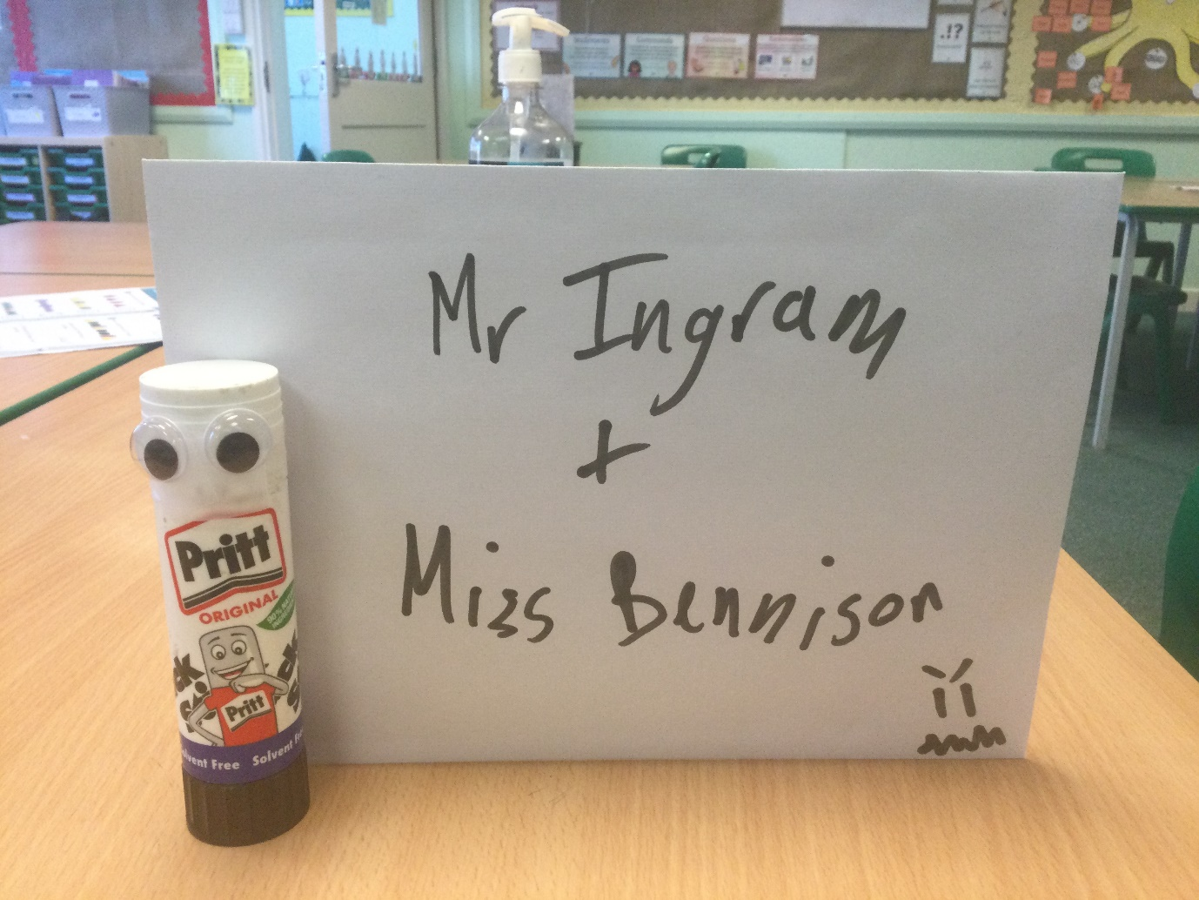
Who is this for? How do you know?
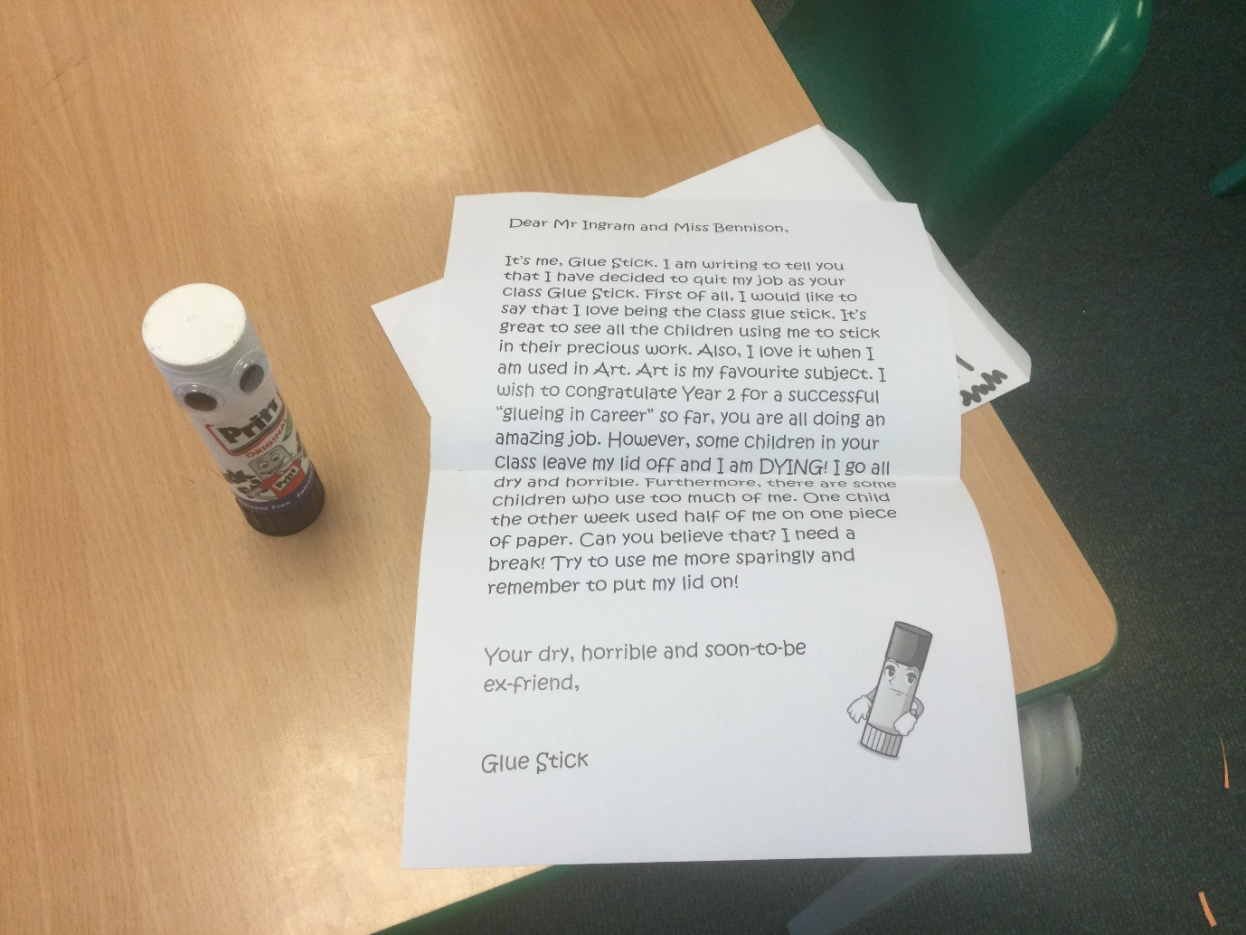
Here is what the letter said:
Dear Mr Ingram and Miss Bennison,
It’s me, Glue Stick. I am writing to tell you that I have decided to quit my job as your class Glue Stick. First of all, I would like to say that I love being the class glue stick. It’s great to see all the children using me to stick in their precious work. Also, I love it when I am used in Art. Art is my favourite subject. I wish to congratulate Year 2 for a successful “glueing in career” so far, you are all doing an amazing job. However, some children in your class leave my lid off and I am DYING! I go all dry and horrible. Furthermore, there are some children who use too much of me. One child the other week used half of me on one piece of paper. Can you believe that? I need a break! Try to use me more sparingly and remember to put my lid on!
Your dry, horrible and soon-to-be ex-friend,
Glue Stick
Main Task
In this lesson we are going to plan a persuasive letter ready for our write up tomorrow. I would like you to pretend that you are an item in the classroom. What could you be?
Helpful ideas:
- a rubber – children always pick bits off me
- a pencil sharpener – I always get thrown and left on the floor
- a pair of scissors – I am always used for cutting paper and nothing else
- the carpet – children always trample their food into me
- a chair – children are forever rocking back and forth on only two legs
What might you be writing to complain about? What things might the you feel upset about? (leaving of lids, using too much glue etc.)
How do you think you would like to be treated in the future?
You are going to plan a letter to the teacher to talk about what is wrong with the way they are being treated, and how they would like to be treated in the future.
Use the planning sheet attached to the blog and plan your letter
Think about the following three things:
• What it likes to do
• What it is complaining about
• What it wants

Success criteria
- Pick an item from the classroom
- Think about what it likes to do
- Think about what it is complaining about
- Think about what it wants
- Produce beautiful handwriting with lead-ins to every letter
- Double check for punctuation and spelling errors

