Cycling Helmets, A

How can a hat save your life? When it is a cycling helmet. A cycling helmet is a type of hat worn by cyclists to protect their head during impact.

How do cycling helmets work?
soft inner liner
hard outer shell
straps

Parts of a Helmet
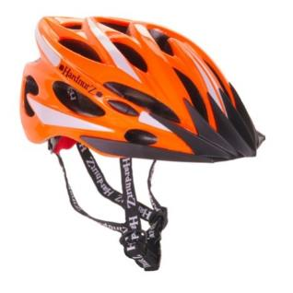
A typical helmet has two main parts: a hard, outer shell and a soft inner liner. The hard shell is designed to spread the force of an impact over a broader area so your skull is less likely to fracture, while the soft liner is meant to squeeze inward and absorb the impact energy, so less of it is transmitted to your head.

Straps are fastened under the chin and are designed to keep the helmet in place because it will only protect the head (and brain) properly if correctly positioned.

Vents are part of the style too, but their true purpose is to make the helmet cooler to wear.

How do they protect us?

Helmets work by bringing the head (and brain) to a relatively gradual stop upon impact. When an unprotected rider strikes his head against a hard surface, inertia causes the brain to slam forward against the skull, which can cause bruising and internal bleeding. Helmets soften the shock by gradually crushing to absorb impact energy. The outer shell will crack but still remain intact. The helmet's body, composed of fused polystyrene beads, is compressed as it absorbs energy to cushion the blow.

How do you wear a cycling helmet correctly?

Choosing a cycling helmet

- First, measure your head with a measuring tape, placing it about 1cm above your eyebrows. Match the measurement to the size information ticket on the helmet.

- Next, try the bike helmet on. Check that it sits low on your forehead, just above your eyebrows. Shake your head to check that it doesn't move.

- Now, secure the straps (adjusting lengths if needed) and check the fit is snug but comfortable.

There are very good reasons to wear a cycling helmet:

- bicycle helmets can reduce the risk of head injury by as much as 85%;
- bicycle helmets can reduce the risk of brain injury by as much as 88%; and
- it is estimated that 75% of bicycle-related deaths among children could be prevented with a bicycle helmet.

So, what are you waiting for? Helmet-up and get pedalling!

