Monday 1st March 2021
Can I explore the physical geography of Italy?
Today we are going to learn about the physical geography of Italy.
Q – What do you think physical geography means? (The answer is at the bottom of the page.)

Look at the physical map of Italy below. (Answers are at the bottom of the page.)
Q – What do you think the brown areas represent?
Q – Why are some areas a darker shade than others?

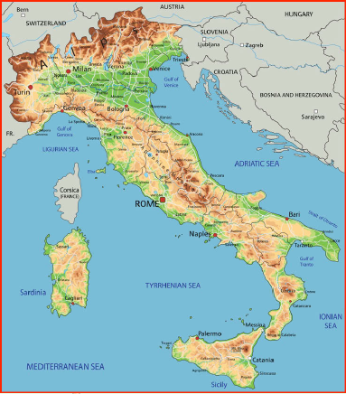
As you can see, Italy is a very mountainous country. There are 2 main mountain ranges.
The Alps
The mountain range which runs for 1200km along the top of Italy and through all of the bordering countries (as well as Germany, Liechtenstein and Monaco) is the Alps.

The Apennines
The mountain range that runs 1200km along the length of Italy (and is often called the backbone of the country) is the Apennines.

The term physical geography is used to describe the natural features and landscape of an area or country, such as its mountains, deserts, rivers and oceans.
The brown colour represents the elevation of the land in that area (how high it is). The darker the brown, the higher it is.

The Alps
Write a subtitle The Alps in your Home Learning Book.
- Click on the link here to explore the Alps and find out more information about this range of mountains.
Answer the following questions in your Home Learning Book and provide some interesting facts about the Alps. You may wish to print out page 3 and shade The Alps on the map, as well as drawing triangles to represent the location of Mont Blanc and The Matterhorn.
- The highest peak in the Alps is Mont Blanc, which translates as ‘white mountain’. Can you find some more information about Mont Blanc? Where is it situated? How tall is it?
- Another mountain in the range is called The Matterhorn. Can you find out some more information about The Matterhorn? Where is it situated? How tall is it?
The Apennines
Write a subtitle The Apennines in your Home Learning Book.
Answer the following questions in your Home Learning Book and find out some more interesting facts about the Apennines. You may wish to shade The Apennines in on the map and draw a triangle to show where Monte Cimone is.
- The highest peak is Corno Grande, which translates as ‘big horn’. It is situated in the central Apennines. Can you find out how tall it is?
- Monte Cimone is the highest mountain in the northern Apennines. Can you find out how tall it is?
The River Po
Write a subtitle The River Po in your Home Learning Book.
Answer the questions below and find out some more interesting facts about the River Po. You could draw the river on your map.
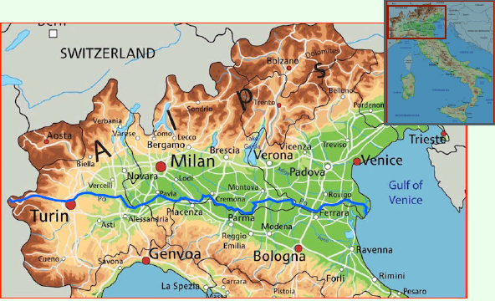
- The River Po flows eastward across the north of the country. It is the longest river in Italy. How long is it?
- Where is the source of the river (where does it begin?)
- Where is the mouth of the river (where does it end?)
- How many tributaries (smaller rivers flowing into it) does it have?

