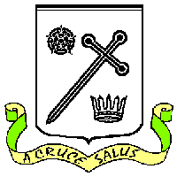
St Oswald’s Catholic Primary School, Longton

REQUEST FOR A BAPTISMAL CERTIFICATE

Full name of child requiring a Baptismal Certificate: ………………..……………………………………………..…………

My child was baptised at St Oswald’s on: …………………………………………..……………………………………….………..

Names of parents/Godparents: ………………………………………………………………….……………………………………………

Home address & telephone no.: ……………………………………………………………………………………………………………………………….………………………………………..
…………………………………………………………………………………………………………………………………………………
…………………………………………………………………………………………………………………………………………………
On completion, please post this form through the letterbox at St Oswald’s Presbytery or leave with the school office. Baptismal Certificates should be collected from the school office.

St Oswald’s Catholic Primary School, Longton

REQUEST FOR A BAPTISMAL CERTIFICATE

Name of child requiring a Baptismal Certificate: ……………………………………………………………………..…………

My child was baptised at St Oswald’s on: …………………………………………………………….…………………….………..

Names of parents/Godparents: ………………………………………………………………………………………………………………

Home address & telephone no.: ………………………………………………………………………………………………………………………………………………….……………………..
…………………………………………………………………………………………………………………………………………………
………………………………………………………………………………………………………………………………………………… On completion, please post this form through the letterbox at St Oswald’s Presbytery or leave with the school office. Baptismal Certificates should be collected from the school office.

