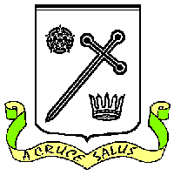
St Oswald's Catholic Primary School St Oswald’s Catholic Community:
Headteacher - Mrs B Wood With Christ at the centre of our

Chapel Lane community, our mission is to live,

Longton love and learn as Jesus taught us.
Preston PR4 5EB
Email head@longton-st-oswalds.lancs.sch.uk Tel: 01772 613402
bursar@longton-st-oswalds.lancs.sch.uk

8th December 2023

Dear Parents of Y5 children

Y5 AUSTRALIAN THEMED CELEBRATION – THURSDAY 21ST DECEMBER

As you will already know, Y5 will be saying good luck and goodbye to their classmate, Ollie, on Thursday 21st December as he sets off to start an exciting life in Australia.

To give Ollie a great send off Miss Smith and Mrs Dexter are planning a special morning and as part of the celebration, Y5 are invited to come to school in Australian themed fancy dress. This could be:
- dressing in red and blue to match the colours of the Australian flag
- dressing in yellow/green to match the colours of the Australian sport kits (PE kit would be the easiest!)
- anything animal related (crocodile, koala, kangaroo etc.)
- anything else you can think of………

The celebration morning will create lovely memories for Ollie and the whole of Y5.

If you need anything clarifying, please contact Miss Smith asap.

Kind regards

B Wood
Headteacher

